**QR Integrity**

**A Project Report Submitted in Partial Fulfilment of**

**the Requirements for the Degree of**

**Bachelor of Technology**

**in**

**Computer Science and Engineering**

**(Artificial Intelligence)**

**by**

**Mr. Yash Srivastava 2003481520023**

**Mr. Kunal Verma 2003481520008**

**Mr. Shiva Kumar 2003481520018**

**Mr. Adib Hussain 2003481520001**

**Under the Supervision of**

**Mr. Amit Kumar Sharma**

**(Assistant Professor)**

**PSIT COLLEGE OF ENGINEERING, KANPUR**

**to the**



**Faculty of Computer Science & Engineering**

**Dr. A.P.J. Abdul Kalam Technical University, Lucknow**

**(Formerly Uttar Pradesh Technical University)**

**May 2024**

# DECLARATION

I declare that this submission is solely my work, and to the best of my knowledge and belief, it does not include any previously published or written material by another person. Furthermore, it does not contain any material that has substantially contributed to the award of any degree or diploma from a university or other institute of higher learning, except where proper acknowledgment has been provided within the text.

Name : Mr. Yash Srivastava

Roll No : 2003481520023

Date :

Signature :

Name : Mr. Kunal Verma

Roll No : 2003481520008

Date :

Signature :

Name : Mr. Shiva Kumar

Roll No : 2003481520018

Date :

Signature :

Name : Mr. Adib Hussain

Roll No : 2003481520001

Date :

Signature :

# ACKNOWLEDGEMENT

It gives us a great sense of pleasure to present the report of B.Tech. Project QR Integrity undertaken during B.Tech. Final Year. We owe special debt of gratitude to our project guide **Mr. Amit Kumar Sharma (Assistant Professor, CSE), PSIT College of Engineering Kanpur** for his constant support and guide throughout the course of our work. His sincerity, thoroughness and perseverance have been a constant source of inspiration for us. It is only his cognizant efforts that our endeavours have seen light of the day.

We also do not like to miss the opportunity to acknowledge the contribution of all faculty members of the department for their kind assistance and cooperation during the development of our project. Last but not the least, we acknowledge our friends for their contribution in the completion of the project.

Name : Mr. Yash Srivastava

Roll No : 2003481520023

Date :

Signature :

Name : Mr. Kunal Verma

Roll No : 2003481520008

Date :

Signature :

Name : Mr. Shiva Kumar

Roll No : 2003481520018

Date :

Signature :

Name : Mr. Adib Hussain

Roll No : 2003481520001

Date :

Signature :

# CERTIFICATE

This is to certify that the project titled QR Integrity - is submitted by

1. Mr. Yash Srivastava (2003481520023)
2. Mr. Kunal Verma (2003481520008)
3. Mr. Shiva Kumar (2003481520018)
4. Mr. Adib Hussain (2003481520001)

in partial fulfillment of the requirement for the award of the degree of Bachelor of Technology in Computer Science and Engineering to PSIT College of Engineering, Kanpur, affiliated to Dr. A.P.J. Abdul Kalam Technical University, Lucknow, during the academic year 2023–24, is the record of the candidate’s own work carried out by him/her under my supervision. The matter embodied in this report is original and has not been submitted for the award of any other degree.

Mr. Abhay Kumar Tripathi Mr. Amit Kumar Sharma

(Head of Dept. of CSE) (Asst. Professor, Dept. of CSE)



# ABSTRACT

In recent years, counterfeit products have proliferated within manufacturing industries, presenting significant challenges to companies in terms of brand integrity, sales, and financial performance. To address this issue, blockchain technology has emerged as a promising solution for verifying genuine products and detecting counterfeit ones. Blockchain operates as a decentralized digital ledger, securely storing transactional data in interconnected blocks across databases. Its inherent security features ensure data immutability, making it highly resistant to tampering or unauthorized modifications. By leveraging blockchain technology, companies can reduce reliance on third-party verification services, enhancing customer confidence in product authenticity.

With the increasing prevalence of mobile and wireless technologies, Quick Response (QR) codes have gained prominence as effective tools for combating counterfeiting. By integrating QR codes with blockchain technology, companies can streamline the detection of counterfeit products through QR code scanning processes. Each product is assigned a unique QR code linked to its corresponding blockchain record, enabling seamless storage and retrieval of product information.

When a QR code is scanned, the system verifies its authenticity by cross-referencing it with entries in the blockchain database. If the QR code matches, the customer receives confirmation of the product's authenticity; otherwise, they are promptly notified of the presence of a counterfeit product. By combining QR codes with blockchain technology, companies can establish a robust authentication system that enhances product traceability and consumer trust. This integrated approach offers a seamless and efficient means of identifying counterfeit products while providing customers with reliable assurance of product authenticity.

**Keywords: -** Blockchain Technology, QR codes, Database, Counterfeit products, Transactional Data.

# TABLE OF CONTENT

**TITLE PAGE………………………………………………………………………. i**

**DECLARATION ii**

**ACKNOWLEDGEMENT iii**

**CERTIFICATE iv**

**ABSTRACT v**

**TABLE OF CONTENT vi**

**LIST OF FIGURES i****x**

**LIST OF TABLES** **x**

**CHAPTER 1: INTRODUCTION 1**

1.1 Introduction to Problem 1

1.2 Importance 2

1.3 Motivation 3

1.4 Problem Statement 4

1.5 Objective 4

1.6 Basic Terminology 5

**CHAPTER 2: LITERATURE REVIEW** **9**

2.1 Existing System 9

2.2 Proposed System 18

2.3 Feasibility Study 22

2.4 Limitation of Existing Work 26

**CHAPTER 3: SOFTWARE REQUIREMENTS 28**

3.1 System Requirement 28

3.2 Functional Requirement 29

3.3 Non Functional Requirement 29

3.4 Analysis Model 30

**CHAPTER 4: SYSTEM DESIGN 3****3**

4.1 System Architecture 33

4.2 Data Flow Diagram 34

4.3 Flow Chart 34

4.4 Block Diagram 35

4.5 Use Case Diagram 36

4.6 Sequence Diagram 37

**CHAPTER 5: PROJECT PLAN** **39**

5.1 Project Estimate 39

5.2 Risk Management 39

5.3 Project Schedule 41

**CHAPTER 6: SYSTEM IMPLEMENTATION** **46**

6.1 Introduction 46

6.2 Tools and Technology Used 47

6.3 Methodology 47

6.4 Algorithm 49

**CHAPTER 7: SOFTWARE TESTING** **54**

7.1: Testing Approaches 54

7.2: Test Case and Test Results 55

**CHAPTER 8: RESULTS** **57**

8.1: Screenshots 57

8.2: Source Code 63

**CHAPTER 9: CONCLUSIONS** **91**

9.1: Conclusion 91

9.2: Future Work 91

9.3: Advantages 92

9.4: Applications 93

**APPENDIX** **95**

List of Abbreviations 95

**REFERENCES** **96**

**PLAGIARISM REPORT** **100**

**CONTACT DETAILS** **101**

# LIST OF FIGURES

**IMAGE NAME** **PAGE NO.**

|  |
| --- |
| 1.6.1 MySQL Database 06 |
| 1.6.2 Proof-of-work 08 |
| 2.1.3 eBay complaint form 12 |
| 2.1.5 Industries suffering counterfeiting 14 |
| 2.1.7 Crypto Anchor Verifier 16 |
| 2.2.1 System Overview 19 |
| 2.2.2 Blockchain Maintaining Records 21 |
| 2.2.3 Blockchain Architecture 22 |
| 3.4.1 Waterfall Model 32 |
| 4.1.1 System Architecture 33 |
| 4.2.1 Data Flow Diagram 34 |
| 4.3.1 Flow Chart 35 |
| 4.4.1 Block Diagram 35 |
| 4.5.1 Use Case Diagram 36 |
| 4.6.1 Sequence Diagram 38 |
| 5.2.1 Risk Management 40 |
| 5.3.1 Task Network 42 |
| 5.3.4 Team Organization 45 |
| 6.3.1 Blockchain Chaining 48 |
| 6.4.1 SHA-256 Working 51 |
| 8.1.1 Home Page 57 |
| 8.2.1 Login Page 57 |
| 8.3.1 User Main Page 58 |
| 8.4.1 Validation Page 58 |
| 8.5.1 Registration Page 59 |
| 8.6.1 Product Authentication Success 59 |
| 8.7.1 Product Retrieval 60 |
| 8.8.1 Product Authentication Failed 61 |
| 8.9.1 Generated QR Code 61 |
| 8.10.1 Real Time QR Scan 62 |
| 8.11.1 Validating Fake QR 62 |
| 10.1.1 Database Schema 90 |

# LIST OF TABLES

**TABLE NAME**  **PAGE NO.**

|  |
| --- |
| 5.1.1 Time Estimate 39 |
| 5.3.3 Timeline Chart 43 |
| 6.3.1 Product Data Table 49 |
| 7.2.1 Test Cases and Test Results 55 |
| 8.1.1 Output.html 60 |

# CHAPTER 1: INTRODUCTION

## 1.1 INTRODUCTION TO PROBLEM

The progression of any product or technology inevitably comes with inherent risks, including the threat of counterfeiting and replication, which can have profound repercussions on a company's standing, financial performance, and the safety of consumers. In today's complex supply chain landscape, encompassing a vast array of products, there arises an urgent need for strategies to verify their authenticity amid the rampant proliferation of counterfeit merchandise. This pervasive challenge has inflicted significant financial losses on manufacturers worldwide. Embracing blockchain technology emerges as a promising solution to establish the genuineness of products.

Blockchain operates as an immutable ledger system, impervious to tampering, hacking, or any form of fraudulent manipulation. It serves as a digital repository of transactions, replicated and distributed across the entirety of interconnected systems within the blockchain network. Each block within the chain encapsulates numerous transactions, with each new transaction appending a record to the ledger of every participant. This decentralized database, collectively managed by multiple participants, embodies the concept of Distributed Ledger Technology (DLT), with blockchain being a leading example. Transactions within blockchain are fortified with cryptographic security, utilizing unalterable signatures called hashes, effectively thwarting attempts at product counterfeiting.

The inherent security features of blockchain technology ensure resilience against unauthorized alterations. Upon a product's entry into the blockchain network, a unique hash code is generated, facilitating the perpetual maintenance of comprehensive transaction records and ownership history in a sequential chain format. Transactional data is securely stored as blocks within the blockchain, safeguarding it from any form of manipulation or deletion. In our proposed system, each product is assigned a distinct QR code, providing end consumers with seamless access to detailed product information. By simply scanning the QR code, consumers can swiftly verify the product's authenticity, thereby mitigating the risks associated with counterfeit products and enhancing trust in the supply chain ecosystem.

## 1.2 IMPORTANCE

This project, which aims to tackle the widespread issue of counterfeit products by integrating blockchain technology into a web application, holds immense importance to me on multiple fronts. First and foremost, it's about protecting consumers like us. Counterfeit goods not only pose health and safety risks but also lead to financial losses. By providing consumers with a reliable way to authenticate products, this project empowers us to make informed decisions, ensuring our well-being and financial security.

1. Equally significant is the preservation of brand integrity. Counterfeiting tarnishes the reputation of legitimate brands, eroding consumer trust and loyalty. Through robust authentication measures, this project strengthens brand integrity, fosters loyalty, and ensures customer satisfaction, benefiting both businesses and consumers alike.
2. Beyond consumer protection and brand integrity, this project has substantial economic implications. Counterfeiting results in significant revenue losses for legitimate businesses and disrupts market dynamics. By reducing the demand for counterfeit products, this project helps mitigate these losses, fostering a fairer and more sustainable business environment.
3. Moreover, this project drives innovation by harnessing emerging technologies such as blockchain and QR code generation. This not only strengthens the fight against counterfeiting but also propels technological advancement, driving economic growth and competitiveness.
4. Additionally, this project aids businesses in meeting regulatory standards and compliance requirements, enhancing consumer trust and regulatory compliance. It also promotes transparency and accountability in global supply chains, reducing the risk of counterfeit infiltration and strengthening supply chain resilience.

Furthermore, this project contributes to environmental sustainability by discouraging the consumption of counterfeit goods, which often lead to environmental pollution and waste. By promoting the purchase of genuine, quality products, this project supports efforts towards a healthier and more sustainable planet.

## 1.3 MOTIVATION

In the contemporary landscape, counterfeit goods have proliferated on a global scale, infiltrating various sectors of the supply chain. Recent reports indicate a surge in incidents involving counterfeit products. Establishing a robust system wherein users can verify comprehensive product details is imperative, empowering them to discern the authenticity of goods. As a solution, a straightforward QR code-based identification system is proposed, enabling end-users to conveniently scan and ascertain the genuineness of products.

Several keys factors can be raised as a motivation:

1. Rising Counterfeit Incidents: There has been a significant increase in counterfeit goods flooding the market across various industries, including fashion, electronics, pharmaceuticals, and more. These counterfeit products not only infringe on intellectual property rights but also pose serious risks to consumer safety and health.
2. Consumer Protection: Counterfeit goods often lack the quality standards and safety regulations adhered to by genuine products. Consumers unknowingly purchasing counterfeit items may experience disappointment due to inferior quality, or worse, encounter health hazards from counterfeit pharmaceuticals or electronics prone to malfunction.
3. Brand Integrity: Counterfeiting not only harms consumers but also undermines the reputation and integrity of legitimate brands. By allowing counterfeit products to circulate unchecked, brands risk losing consumer trust and loyalty built over years of delivering genuine, quality products.
4. Need for Verification: In the digital age, consumers expect transparency and accountability from brands. Providing a means for consumers to easily verify the authenticity of products instills confidence in the brand and fosters a sense of trust between the brand and its customers.
5. Technological Advancements: With the widespread use of smartphones and QR code scanning technology, implementing a QR code-based identification system is feasible and cost-effective along with the blockchain technology which is known for providing security and transparency to everyone part of the network. It leverages existing infrastructure to provide a seamless solution for consumers to verify product authenticity.

## 1.4 PROBLEM STATEMENT

The expansion of a product or innovation on a global scale often brings along risks such as counterfeiting and duplication. Both the company's reputation and customer safety are jeopardized by counterfeiting. Detecting counterfeit items has become a significant challenge in today's market. The proliferation of counterfeit goods has detrimental effects on both businesses and consumer welfare, leading to substantial hardships for product manufacturers. Countries like India are actively combating the circulation of counterfeit goods. So the issue of counterfeiting avoidance arises which is actively practiced by people who want to take advantage of both customers and the companies. A proposed solution involves the utilization of Blockchain technology to generate QR codes. Within this technology, transaction records are stored in blocks, ensuring the integrity and security of the data. QR codes serve as an effective tool in identifying counterfeit goods.

## 1.5 OBJECTIVE

The concept for initiating this project stemmed from the escalating prevalence of counterfeit products. The objectives of this endeavor encompass:

i. Developing an anti-counterfeiting system leveraging blockchain technology which can store transactional data to ensure valid transactions of real products.

ii. Safeguarding product information through QR code integration and providing an easy way to utilize the technology.

iii. Ensuring customer security by empowering them with control and access over transactional data of the products.

## 1.6 BASIC TERMINOLOGY

**1. Python**

Python stands out as a versatile and widely embraced programming language, valued for its high-level nature and broad applicability across various domains. Employed in web development, machine learning, and other cutting-edge fields within the software industry, Python (specifically the latest Python 3 iteration) serves as a cornerstone for innovative applications. Its utility extends to server-side web development, software engineering, mathematical computations, and system scripting, owing to its rich set of built-in data structures, dynamic typing, and dynamic binding capabilities. Python's appeal lies in its support for rapid application development and its role as a scripting or integration language for amalgamating existing components. Notably, Python's syntax is easily comprehensible, fostering code readability and minimizing program maintenance overheads. Furthermore, its modular architecture, coupled with robust support for modules and packages, promotes code reuse and facilitates the development of scalable and maintainable software solutions. As an open-source language, Python benefits from a vibrant community of developers continuously enriching its ecosystem with new libraries and functionalities, ensuring its relevance and adaptability in evolving technological landscapes.

**2. MySQL database**

MySQL database is a widely utilized relational database management system (RDBMS) renowned for its versatility and widespread adoption across various industries. Serving as a foundational component in numerous software applications and web development projects, MySQL is prized for its reliability, scalability, and performance. It facilitates the efficient organization and retrieval of data through structured query language (SQL), making it suitable for diverse use cases ranging from small-scale websites to enterprise-level systems. MySQL's seamless integration with popular programming languages such as Python, PHP, and Java further enhances its appeal, enabling developers to build robust, data-driven applications with ease. Its open-source nature fosters a vibrant community of developers contributing to its ongoing development and enhancement. Additionally, MySQL offers comprehensive features for data security, transaction management, and data replication, ensuring the integrity and availability of critical data. Overall, MySQL database stands as a cornerstone in the realm of data management, empowering organizations to efficiently store, retrieve, and manipulate data to meet their evolving needs and objectives.



Figure 1.6.1: MySQL Database

**3. Encryption**

Encryption serves as a pivotal component in modern cybersecurity, facilitating the secure transmission and storage of sensitive information across various digital platforms. Employed in diverse domains such as communication, data storage, and financial transactions, encryption ensures confidentiality, integrity, and authenticity of data. By transforming plaintext into ciphertext using cryptographic algorithms, encryption renders data unreadable to unauthorized individuals, thus safeguarding it from interception or unauthorized access.

Furthermore, encryption plays a crucial role in compliance with data protection regulations and standards, such as the General Data Protection Regulation (GDPR) and the Health Insurance Portability and Accountability Act (HIPAA), by ensuring that sensitive information remains protected from breaches and unauthorized disclosure.

Moreover, encryption technologies continue to evolve to meet the challenges posed by emerging threats and advancements in computing capabilities. From traditional symmetric key encryption to advanced techniques like public key infrastructure (PKI) and homomorphic encryption, organizations have a plethora of options to choose from based on their specific security requirements and operational needs.

**4. Proof-of-work**

Proof-of-work (PoW) is a foundational concept in blockchain technology, serving as the underlying mechanism for achieving consensus and validating transactions in decentralized networks. Originating with Bitcoin, PoW has become a cornerstone of numerous cryptocurrencies and blockchain-based systems, ensuring the integrity and security of distributed ledgers.

At its core, PoW requires participants, known as miners, to solve complex mathematical puzzles in order to validate and add new blocks to the blockchain. These puzzles are computationally intensive and require significant computational power to solve, thereby serving as a deterrent against malicious actors attempting to manipulate the ledger.

The process of solving these puzzles involves repeatedly hashing potential solutions until a hash with specific properties, known as the target hash, is found. This process, often referred to as mining, consumes computational resources and energy, incentivizing miners to compete for the opportunity to validate transactions and earn rewards in the form of newly minted cryptocurrency coins.

PoW ensures the security and immutability of the blockchain by making it economically infeasible for an attacker to alter transaction history or double-spend coins. The decentralized nature of PoW also mitigates the risk of a single point of failure, as the network relies on a distributed consensus mechanism rather than a centralized authority.

However, PoW is not without its drawbacks. It requires a significant amount of energy to maintain the network, leading to concerns about its environmental impact and sustainability. Additionally, PoW can be vulnerable to certain types of attacks, such as 51% attacks, where a malicious actor gains control of a majority of the network's computational power.

Despite these challenges, PoW remains a widely adopted consensus mechanism in blockchain technology, providing a robust foundation for secure and decentralized peer-to-peer transactions.

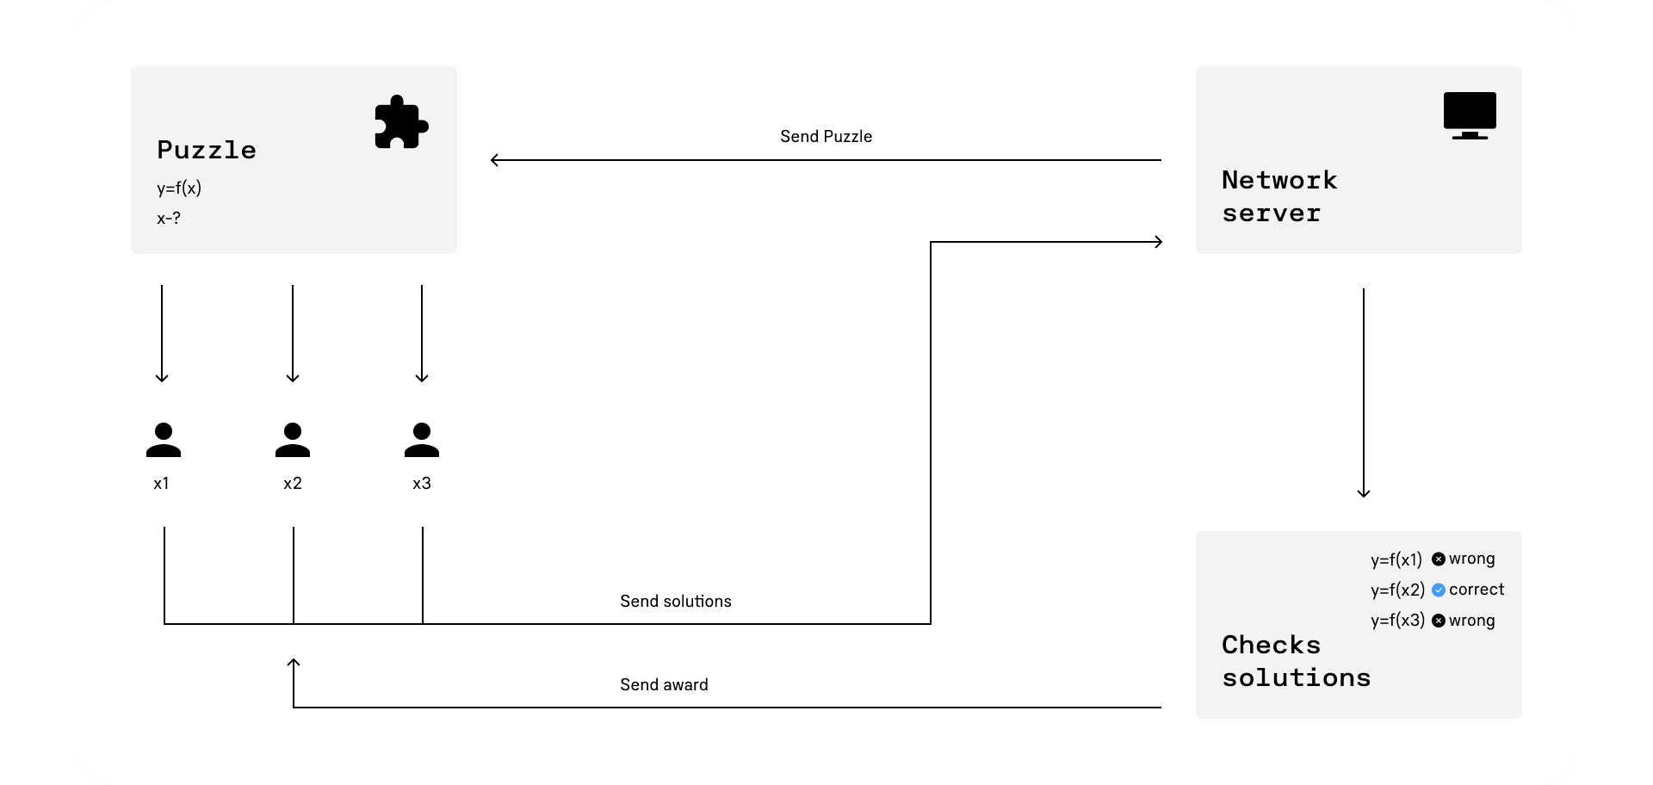

Figure 1.6.2: Proof-of-work Mechanism

# CHAPTER 2: LITERATURE REVIEW

## 2.1 EXISTING SYSTEM

### 2.1.1. RFID Anti- Counterfeiting for Retailing Systems

Counterfeiting product is one of the serious problems that most product manufacturers and customers have to confront. The intent to make counterfeiting products is to take advantage of the original value of the genuine products. According to the report of International Chamber of Commerce (ICC), the global market loss due to counterfeiting products reaches $1.7 trillion by 2015. As a result, several countermeasure solutions have been proposed such as the barcodes, the hologram stickers, and the Radio-Frequency Identification (RFID) tags. Among the aforementioned countermeasures, RFID technology is the most viable solution for product anti- counterfeiting due to the difficulty for the adversary to access to the sensitive information, e.g., the tag identity and the tag authenticity, of the RFID tag. Typically, each tag is equipped with an authentication protocol which provides more rigorous access control to the tag information. The verifier has to successfully pass the authentication procedure to get this information. Thus, the RFID tag with an authentication protocol is a viable and proactive solution for anti-counterfeiting. Currently, the tag-side authentication protocol and the mutual authentica-tion protocol have been proposed for anti-counterfeiting.

Obviously, the latter protocol is more secure than the former protocol as it requires both sides of the protocol - the server and the tag-to get authenticated. However, we argue that the mutual authentication protocol is inap-propriate for use in product retailing systems. First, since the mutual authentication protocol takes time to au-thenticate the server, to update and to synchronize the secret shared between the server and the tag, it in-creases the computation and the communication cost whereas most of the tags used in consumer products has weak computational resources. Second, the update and synchronization of the secret shared between the tag and the server can be suffered from the de-synchronization problem. Finally, if the server authenticity must be taken into account, the tag might intentionally refute the authentication request from the verifier by abusing the server authenticity. Instead, customers should be able to verify any tag without hindrance from the tag. Thus, a secure tag-side authentication protocol where tags have to answers their proof of authenticity for any request is sufficient for use in the retailing system. Additionally, the current proposed RFID authentication systems for anti-counterfeiting do not consider the role of the product seller. These systems consist of three parties: the RFID tag, the reader, and the server. Meanwhile, the sellers/retailers always exists in the retailing system. Hence, in this paper, our anti-counterfeiting system considers the role of the seller. In the retailing system, a seller who distributes products can be either an authorized entity or an unauthorized one. If a seller is honest (authorized), he can support the product anti- counterfeiting systems. In contrast, if the seller is dishonest (unauthorized), he may conspire with the adversary in selling counterfeit products along with the genuine ones in his shop. Thus, to improve the anti-counterfeiting capability, we need a mechanism in which the seller has to support the anti-counterfeiting whilst refraining him from being dishonest. The contributions of our paper are summarized as follows:

1. We propose an RFID-based anti-counterfeiting system consisting of two protocols: the tag authentication protocol and the database correction protocol. The tag authentication protocol increases the usability for the customers by allowing them to authenticate RFID tags without the need of authenticating the reader and the server. Meanwhile, the database correction protocol helps the seller and the server to update the tag status in the server database periodically.
2. The proposed anti-counterfeiting system is secure against various attacks such as RFID tag counterfeit, seller impersonation, server impersonation and the database spoiling attack. Further, the proposed system not only allows the customer to detect the counterfeit tags, but also reduces the market loss due to counterfeit prod-ucts.

### 2.1.2. Research on Anti- counterfeiting Technology Based on QR Code image Watermarking Algorithm

This paper introduces a novel anti-counterfeiting approach alongside a highly robust digital watermarking algorithm utilizing Discrete Wavelet Transform (DWT) and Singular Value Decomposition (SVD). The methodology involves utilizing a QR code as the carrier image, generated from pertinent information of the copyright owner, and subsequently embedding the copyright owner’s details into the QR code as a watermark. The extraction of watermark information from the QR code is accomplished through watermark detection and two-dimensional barcode scanning tools. Authentication of the QR code's legitimacy is achieved by verifying the watermark information and scanning data. Experimental results demonstrate the method's resilience against compressive, rotational, and noise attacks. The proposed scheme and algorithm offer a robust solution for anti-counterfeiting technology in the realm of currency security.

### 2.1.3. Analysis of known methods of identifying the originality of goods

The distribution of counterfeit products is both material and harmful to health. To stay afloat and minimize losses, companies must develop methods to identify genuine products to enable the buyer and various inspection services to distinguish the original from the counterfeit. There are several basic methods of product detection, from traditional to technological.

**Legislative**

This method is based on the buyer's confidence in the actions of the state to ban and seize counterfeit goods. Simply put, if the product is sold publicly and is still not banned, then it is the original. Many modern countries take the issue of counterfeiting seriously and severely punish the distribution of such products. The method mainly depends on the fact that the person who buys a counterfeit product will complain about it and, depending on the result, the source of distribution will be blocked. The Save Harbor approach works in Europe and America. It imposes certain restrictions on online stores and works as follows. The intermediary between the seller and the buyer is released from liability for copyright infringement if he complies with two requirements:

1. It is possible to file a complaint;
2. Reseller responds to complaints (removes or blocks infringing content)

With this approach, you can show confidence in those sellers who are in the market for a long time. Fines for distributing counterfeit products are usually significant. Thus, in China, the fine for violating these rules is $ 7,200 - $ 72,000, and if counterfeit products threaten the buyer's health, the fine can reach $ 288 thousand.

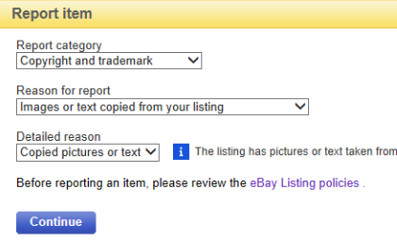

Figure 2.1.3: eBay complaint form

**Pros of the approach:**

1. Regulated by law;
2. It does not require significant material investments for implementation.

**Cons of the approach:**

1. Based on trust;
2. Accuracy is low;
3. Unable to authenticate for time-tested stores.

### 2.1.4. Improving Fake Product Detection Using Ai-Based Technology

An AI-powered solution has the potential to significantly reduce the proliferation of counterfeit products, offering a practical and accessible approach to verifying their authenticity. By leveraging sophisticated algorithms and machine learning capabilities, this innovative system can detect and eliminate fake items without relying on specialized equipment. Consumers can benefit from a trustworthy and convenient method to ensure the legitimacy of products, instilling confidence in their purchases and promoting a transparent market environment. This technology-driven solution holds the promise of transforming industries by combatting counterfeit products effectively.

### 2.1.5. Distribution of counterfeit products and consequences

It would be a mistake to think that counterfeit products are uncommon and quickly punishable by law. This problem has long harmed many countries and companies, causing billions in losses and taking hundreds of lives. For example, in 2017, counterfeit products caused global losses of 323 billion dollars, which is a considerable amount. The largest suppliers of counterfeit products are:

1. China ~ 54%;
2. Hong Kong ~ 27%;
3. Turkey ~ 4%;
4. Singapore ~ 2%;
5. Germany ~ 1%;
6. India ~ 1%;
7. Macedonia ~ 0.9%;
8. Thailand ~ 0.8%;
9. Malaysia ~ 0.7%.

China is a leader in the production of counterfeit products globally, which is not surprising because China is also not a leader in the production of original products. Thus, countries with low labour costs create counterfeits and sell them in the first world, earning vast amounts of money. The countries most affected by such products are the following:

1. USA - 24%;
2. France - 17%;
3. Italy - 15%;
4. Switzerland - 11%;
5. Germany - 9%;
6. Japan - 6%;
7. South Korea - 3%;
8. Britain - 2%;
9. Other countries - 13%

Data collected for 2014-2016 by the Organization for Economic Co-operation and Development (from now on OECD). Since most counterfeits are created on companies' products in the United States, the latter suffers the most significant losses. We think everyone at least once noticed the goods of improper quality on the shelves of markets or supermarkets or when receiving a delivery from an online store. The buyer is disappointed in the store or in the manufacturer of the product, respectively, reducing the following profits. At the same time, no one can avoid the risk zone of counterfeit goods because this network has penetrated almost all areas of production of goods, so you need to inspect and check the goods when buying carefully. Fig. 1 shows world statistics on industries that suffer losses from counterfeit goods according to OECD.

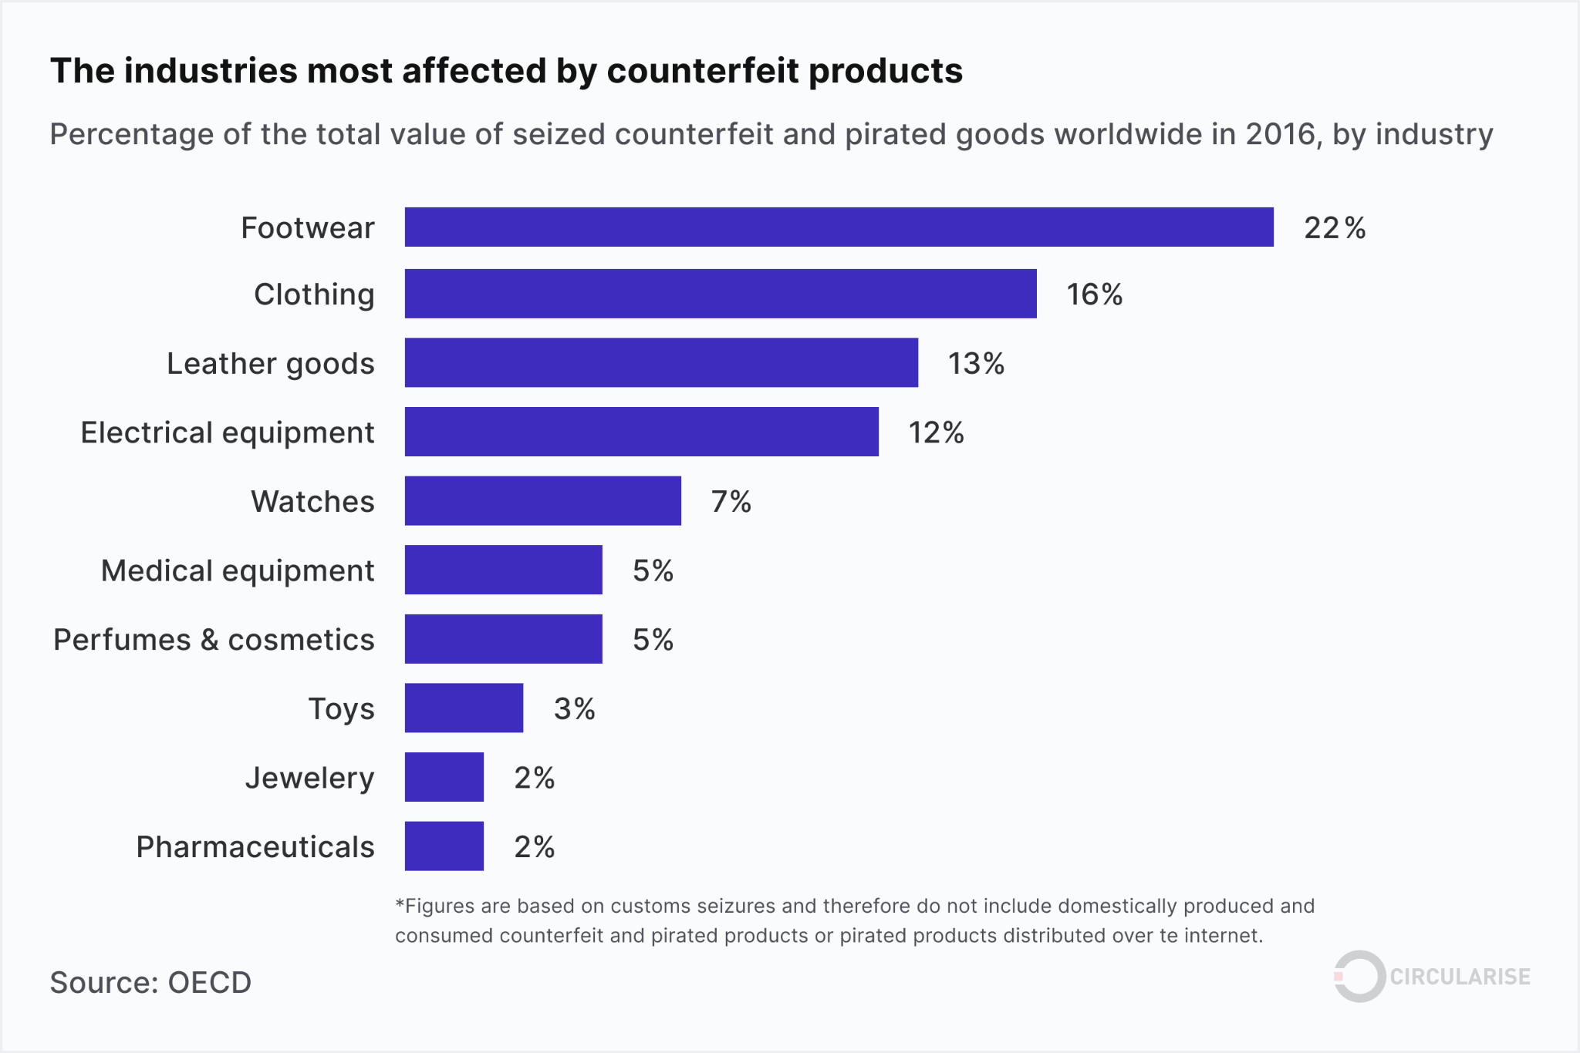

Figure 2.1.5: The industries that suffer the most from counterfeiting

Not surprisingly, in the first places of this ranking are the elements of appearance. Many people want to wear fashionable things, but not everyone has the means to do so. Someone deliberately buys fakes, and someone is led to unrealistically low discounts. The companies themselves achieve a substantial reduction in the cost of such products: they use cheaper and lower quality analogues of original materials, save on quality and production conditions, less monitor the lack of goods. So an inexperienced buyer can easily be given a substitute for natural leather. Given the low savings on the production of counterfeits, it is pretty challenging to distinguish counterfeit from the original. It is such counterfeits that cause the most damage to the owners of the original.

### 2.1.6. A Survey of Counterfeit Product Detection

This research paper thoroughly explores a diverse range of methodologies aimed at effectively identifying counterfeit products. By analyzing and comparing multiple techniques, it provides comprehensive insights into the latest advancements in counterfeit detection, including but not limited to artificial intelligence, blockchain, holography, and forensic analysis. This comprehensive examination equips stakeholders with valuable knowledge to combat the proliferation of counterfeit goods and protect consumer interests.

### 2.1.7. Use of artificial intelligence to detect counterfeit

Aspects of machine learning are deeply rooted in our daily lives. It is a compelling technology that can automate the work of many people. The prospects of this technology are especially tracked in recognition of something, and the detection of counterfeit goods is no exception. Different companies have already started using artificial intelligence for similar purposes and in different ways. Alibaba group uses the latest developments in the field of machine learning to detect ads for counterfeit products. The developed system allows to detect of counterfeits on the following grounds:

1. Price: the system detects unrealistic changes from the expected price and considers possible seasonal discounts, currency conversion, and the fact that the product can be used.
2. Image: The system can detect the slightest deviations in the photos of potentially fake ads. When a critical number of variations is reached, the program notifies of product suspicion.
3. Description: the system analyzes the description of the algorithm to search for suspicious phrases. The original goods do not need to impose their authenticity or novelty on the buyer. Respectively, the algorithm considers similar details.

Because the system is based on learning rather than a specific algorithm, the accuracy cannot be 100%. Potential flaws are possible, and the more goods are analyzed, the more legal interests can be counterfeited. That is why such a system can work only in a semi-automatic mode because the ban on legal goods can cause problems with the law. According to a 2018 report, Alibaba confiscated $ 536 million worth of counterfeit goods from third-party vendors. IBM has demonstrated another way to use artificial intelligence to detect counterfeits in its Crypto Anchor Verifier product. This latest technology is a micro-scanner that can be built into the cameras of mobile phones and perform a detailed analysis of the product's material and on this basis to conclude about its authenticity. The system contains data about the original product, and based on them, artificial intelligence notices differences with counterfeit products and draws conclusions based on the results of comparisons. Initially, the system was developed to recognize the authenticity of diamonds and, after successful use, the company quickly realized the potential of such technology.

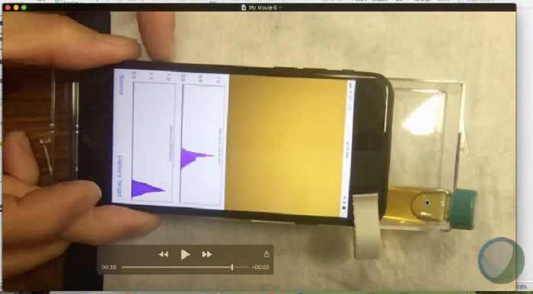

Figure 2.1.7: Crypto Anchor Verifier in action

After developing and refining training algorithms, the system successfully analysed the materials of such goods like wine, clothing, medicine, precious stones, etc. The system can distinguish expensive wine from cheap, recognize genetically modified products, analyse water quality and even find bacteria by type of Escherichia coli. In general, the technology is up-and-coming shortly we can expect the fruits of its widespread use.

**Pros of the approach:**

1. Reliability is high.
2. Cheap to use.
3. Works in a semi-automatic mode.
4. The popularity of machine learning technology makes it easier to gain the trust of the buyer .

**Cons of the approach:**

1. The technology remains inaccurate.
2. The development of such systems can take a long time.
3. Requires additional implementation efforts.

### 2.1.8. Anti-Counterfeit Product System Using Blockchain Technology

Blockchain technology is widely recognized for its robust security and privacy, empowering users with easy access to reliable information through a distributed network. Particularly in the realm of finance and fintech, companies are rapidly adopting blockchain due to its beneficial features. Leveraging blockchain, the proposed system facilitates efficient identification and eradication of counterfeit products from the supply chain and retail markets. This empowers users to make informed choices, build trust with sellers and manufacturers, and eliminate the need for third-party verification. Manufacturers can focus on customer feedback, enhancing services while mitigating economic losses. Blockchain's stability and trust-building potential can significantly bolster a country's economic growth and safeguard against fraud, presenting a secure and user-friendly trade system, truly a game-changer for companies.

### 2.1.9. Product Authentication Using Blockchain

Over the past few years, blockchain technology has witnessed significant adoption and emerged as a crucial component in various domains, including social and legal industries, finance, smart property, and supply chain networks. While decentralized applications (dApps) have evolved into a lucrative market, their development and maintenance costs remain high. Blockchain technology offers data immutability, integrity, and security, eliminating the need for intermediaries. The future holds promising advancements in dApps built on the Ethereum blockchain.

## 2.2 PROPOSED SYSTEM

The proposed system presents an innovative Web application designed to combat the rampant spread of counterfeit products by leveraging the power of blockchain technology. This sophisticated framework seamlessly integrates blockchain functionality into QR code generation, thereby establishing a robust and foolproof method for authenticating goods. Here's a more detailed breakdown of the system's components and features:

The core of the system lies in its utilization of blockchain technology, which serves as the backbone for securely storing and managing product information. Each product is assigned a unique QR code during the manufacturing process. This QR code acts as a digital fingerprint, intricately linked to a corresponding entry in the blockchain ledger. Within this ledger, vital product details, such as manufacturing date, batch number, and origin, are securely stored, ensuring tamper-proof authenticity verification.

Furthermore, the system incorporates MySQL database functionality to store comprehensive manufacturer credentials. This includes essential information such as manufacturer names, email addresses, phone numbers, and encrypted passwords. Each manufacturer is assigned a unique user ID, facilitating seamless authentication and access to the system's features.

When a consumer encounters a product, they can simply scan its QR code using the Web application. Upon scanning, the application prompts the user to enter their corresponding user ID and password. This authentication step ensures secure access to the system's features while safeguarding sensitive information.

Once authenticated, the system cross-references the scanned QR code with the blockchain database to retrieve the associated product information. Simultaneously, it queries the MySQL database to validate the manufacturer's credentials and retrieve additional details if necessary.

In the event of a successful match, the application displays comprehensive product information to the user, including manufacturing details, authenticity status, and manufacturer contact information. However, if a discrepancy is detected between the scanned QR code and the blockchain records, or if invalid manufacturer credentials are provided, the application promptly alerts the user, signaling a potential counterfeit product.

By harnessing the combined capabilities of blockchain and QR code technologies, this Web application empowers consumers with an efficient and trustworthy means to authenticate products and safeguard against counterfeit goods. Through seamless integration with MySQL for storing manufacturer credentials, the system ensures comprehensive security and data integrity, thereby enhancing user trust and confidence in their purchasing decisions.

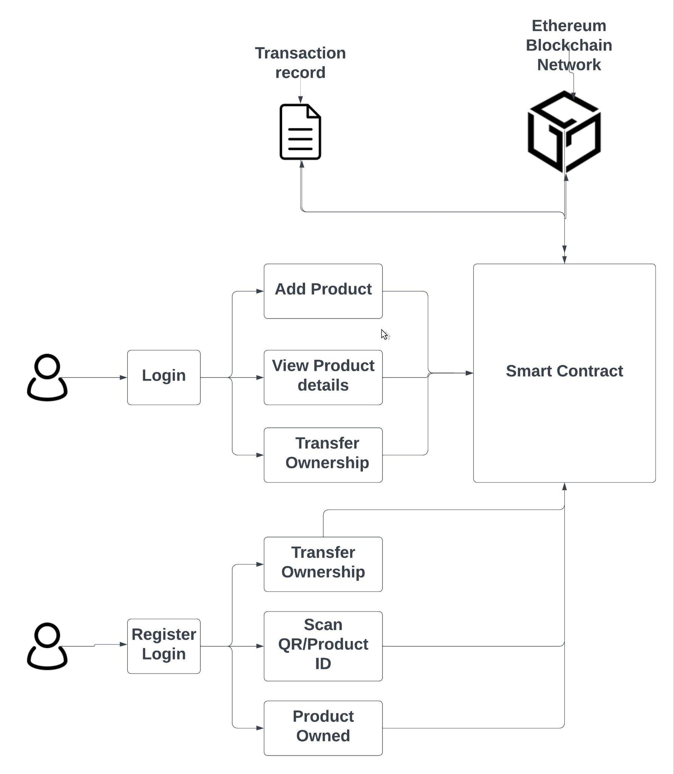

Figure 2.2.1: Overview of the system

**Blockchain Feature:**

In contemporary society, a significant portion of economic transactions relies heavily on trust, often involving two parties interacting with a third party, thereby establishing a trust relationship. Historically, trust guarantees provided by third parties have been fundamental to such interactions. Hence, it's crucial to recognize how Blockchain technology can disrupt the longstanding foundation of human transactions.

Blockchain enables the creation of a data recording system independent of trusted third parties, fostering openness and reliability simultaneously. Below are the key characteristics of Blockchain technology:

1) Security and Privacy: Blockchain employs public key encryption in cryptography to safeguard data. Users generate their key pairs, consisting of a private key for data signing and a public key for verification. By safeguarding the private key, data remains secure. Additionally, Blockchain ensures user anonymity through multiple addresses, enhancing privacy protection.

2) Decentralization: Each node in Blockchain independently manages verification, delivery, and information storage, eliminating the need for centralized control. This decentralized approach fosters autonomy and self-sufficiency within the system.

3) Immutability: Once a block is confirmed within the Blockchain, it becomes resistant to tampering. Any attempt to alter a block is swiftly detected and rejected by other nodes, ensuring data integrity and trustworthiness.

4) Transparency: Blockchain maintains a public ledger accessible to all, facilitating transparent information sharing. Every transaction is recorded and visible to participants, promoting accountability and trust in the system.

5) Flexibility: Blockchain technology is open-source, allowing for modification and adaptation to suit diverse needs. Numerous flexible Blockchain platforms already exist, and users have the freedom to develop customized solutions. Its unlimited potential enables the creation of various applications built upon Blockchain technology.

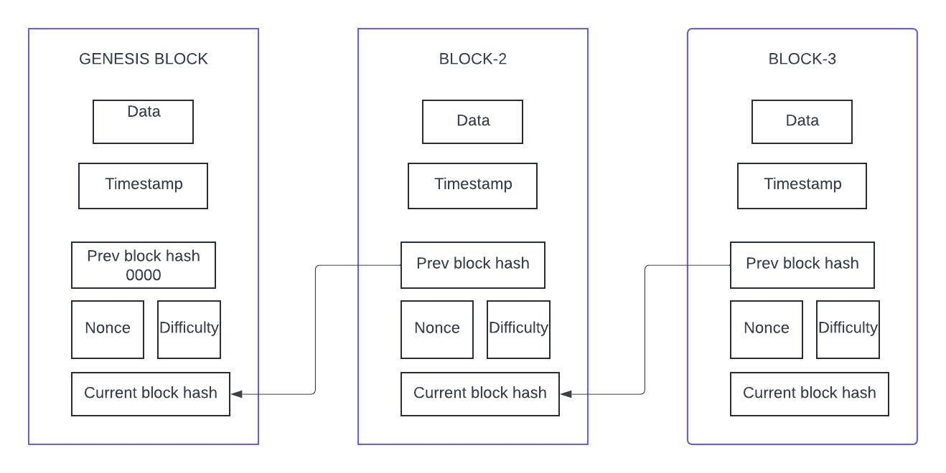

Figure 2.2.2: Blockchain maintaining records

**Blockchain Architecture:**

Blockchain architecture encompasses the foundational structure and design principles governing the operation of blockchain networks. At its core, blockchain architecture is decentralized, eliminating the need for intermediaries and relying on a distributed network of nodes to maintain the integrity of the system. These nodes collaborate to validate transactions, store a copy of the blockchain ledger, and ensure consensus on the state of the network. Key components of blockchain architecture include nodes, consensus mechanisms, blocks, smart contracts, cryptography, and network protocols. Nodes serve as individual participants in the network, while consensus mechanisms establish agreement among nodes regarding the validity of transactions. Blocks group transactions into immutable records, linked together in a chain with cryptographic hashes. Smart contracts enable automated and trustless execution of agreements, while cryptography secures transactions and ensures data integrity. The network protocol governs communication between nodes, facilitating transaction broadcasting, ledger synchronization, and consensus formation. Overall, blockchain architecture plays a pivotal role in shaping the security, scalability, and functionality of blockchain networks, whether in public, private, or hybrid settings.

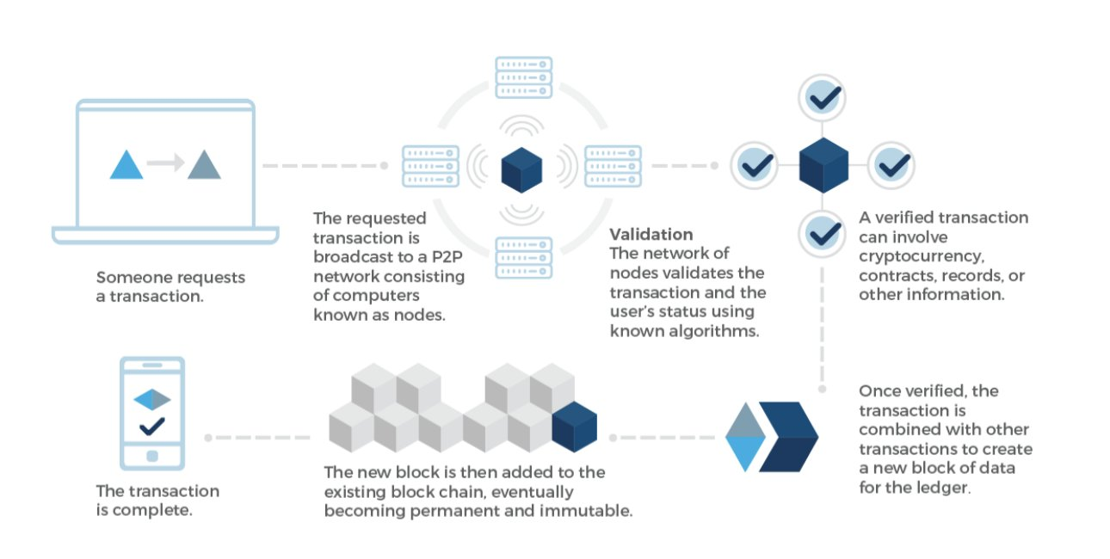

Figure 2.2.3: Blockchain Architecture

## 2.3 FEASIBILITY STUDY:

The system's overall viability hinges on its affordability, scalability, security, and ease of deployment.

Firstly, cost-effectiveness emerges as a paramount consideration. The blockchain-based alternative must not only present upfront cost savings but also demonstrate substantial long-term economic benefits compared to traditional methods. This entails a comprehensive analysis of initial investment requirements, ongoing operational expenses, and potential return on investment. Moreover, stakeholders should carefully evaluate the potential for cost reductions through increased efficiency, decreased reliance on intermediaries, and enhanced transparency afforded by blockchain technology.

Secondly, scalability plays a pivotal role, particularly in accommodating the potential influx of users. Whether the blockchain solution is intended for a small-scale application or a large-scale enterprise operation, its capacity to seamlessly handle transaction volumes and user growth is critical. Scalability solutions such as sharding, sidechains, or off-chain protocols may need to be explored to ensure the system can scale effectively without sacrificing performance or decentralization.

Furthermore, security stands as a non-negotiable aspect of any blockchain implementation. The blockchain solution must not only meet but ideally exceed the security standards of its non-blockchain counterparts. Comprehensive security measures, including robust encryption, multi-factor authentication, and consensus mechanisms, must be integrated to safeguard sensitive data and transactions. Additionally, thorough risk assessments and vulnerability testing are imperative to identify and mitigate potential threats effectively.

Finally, ease of deployment is essential for successful adoption and operation. The blockchain solution should offer intuitive interfaces, seamless integration with existing systems, and comprehensive documentation to facilitate smooth implementation processes. Moreover, ongoing support and maintenance services should be readily available to address any technical issues or updates promptly.

By meticulously evaluating these critical factors, stakeholders can confidently determine the feasibility of adopting blockchain-based solutions and ensure they meet the necessary criteria for successful implementation and operation.

#### **2.3.1 Technical Feasibility:**

While technical factors are undoubtedly important in evaluating systems, a comprehensive feasibility assessment should consider a broader range of criteria. While inputs, outputs, programs, and procedures are crucial aspects of system requirements, feasibility should also encompass factors such as cost-effectiveness, scalability, security, and user acceptance.

Technical issues, such as compatibility with existing technology and scalability, are indeed critical considerations. However, feasibility assessments should also address broader concerns, including organizational readiness, regulatory compliance, and stakeholder expectations.

The project's design should prioritize core functionality and performance while ensuring scalability for future growth. Modern technology was utilized in the project's development to mitigate concerns about obsolescence. While technology may evolve over time, backward compatibility and support for older versions help mitigate constraints associated with technological advancements.

In summary, while technical factors are integral to a feasibility assessment, a holistic approach considering various aspects beyond technology is essential for ensuring the success and sustainability of a system.

#### **2.3.2 Economic Feasibility:**

While technical factors undoubtedly hold significant weight in evaluating systems, a comprehensive feasibility assessment demands a broader perspective encompassing a diverse range of criteria. While inputs, outputs, programs, and procedures constitute crucial aspects of system requirements, feasibility must extend its scope to factors such as cost-effectiveness, scalability, security, and user acceptance.

Indeed, technical issues like compatibility with existing technology and scalability are pivotal considerations. However, feasibility assessments should transcend these technical aspects to address broader concerns that can profoundly impact the success of a project. These concerns encompass organizational readiness, regulatory compliance, stakeholder expectations, and societal implications.

The project's design must prioritize core functionality and performance while also ensuring adaptability and scalability for future growth. Incorporating modern technology into the project's development not only enhances its efficiency and effectiveness but also mitigates concerns about technological obsolescence. While technology inevitably evolves over time, ensuring backward compatibility and support for older versions helps alleviate constraints associated with rapid technological advancements.

In essence, while technical factors undoubtedly constitute an integral part of a feasibility assessment, adopting a holistic approach that considers various dimensions beyond technology is imperative for ensuring the success, sustainability, and broader impact of a system. Such an approach fosters a deeper understanding of the system's implications within its operational context and facilitates the alignment of technical solutions with organizational objectives and stakeholder needs.

#### **2.3.3 Behavioral Feasibility:**

In evaluating the feasibility of a project, it's essential to address key questions that go beyond technical considerations. One critical aspect involves assessing whether there is sufficient support for customers. This encompasses not only the availability of resources and assistance but also the responsiveness and effectiveness of customer service channels. Adequate customer support ensures that users can navigate the system smoothly, troubleshoot any issues efficiently, and maximize the benefits of the proposed solution.

Additionally, it's crucial to consider whether the implementation of the proposed system will inadvertently cause harm or negative repercussions. This involves conducting thorough risk assessments to identify potential pitfalls, vulnerabilities, and unintended consequences. Mitigation strategies should be devised to minimize any adverse impacts on stakeholders, whether they be customers, employees, or the broader community. By proactively addressing these concerns, the project can proceed with confidence, knowing that steps have been taken to safeguard against potential harm.

Moreover, the viability of the project extends beyond technical functionality to encompass its usefulness and alignment with design and customization goals. A project's utility lies in its ability to fulfill identified needs, solve specific problems, or enhance existing processes. Therefore, a thorough evaluation of the project's design and customization features is essential to ensure that it effectively meets the intended objectives and user requirements.

Furthermore, assessing the behavioral feasibility of the project involves examining how well it aligns with user behaviors, preferences, and workflows. This includes considering factors such as user interface design, accessibility features, and compatibility with existing workflows. By carefully evaluating these behavioral components, stakeholders can gain confidence in the project's ability to be seamlessly integrated into existing systems and workflows, thereby enhancing user acceptance and adoption.

In conclusion, a comprehensive feasibility assessment encompasses not only technical considerations but also broader questions related to customer support, potential harm, usefulness, and behavioral alignment. By addressing these key questions, stakeholders can make informed decisions about the viability and desirability of the project, ensuring its success and sustainability in the long run.

## 2.4 LIMITATION OF EXISTING WORK

1. Cost and Complexity:

1. Implementing and maintaining technologies like blockchain or AI can be expensive.
2. High costs may be prohibitive for smaller businesses or industries with limited budgets.

2. Accuracy and Reliability:

1. Technologies like AI or blockchain may not always provide 100% accuracy in detecting counterfeit products.
2. False positives or false negatives can undermine trust in the system's effectiveness.

3. Implementation Challenges:

1. Integrating new technologies into existing supply chains or retail systems is complex and time-consuming.
2. Cooperation among stakeholders and resistance to change may impede implementation efforts.

4. Adaptation and Scalability:

1. Solutions like blockchain-based systems require widespread adoption to be effective.
2. Achieving universal adoption across industries and regions may take time and encounter resistance.

5. Technological Barriers:

1. Not all companies or regions have the technological infrastructure or expertise to implement advanced anti-counterfeiting technologies.
2. Disparities in technological capabilities may widen the gap between those who can combat counterfeiting effectively and those who cannot.

6. Privacy Concerns:

1. Systems collecting and analyzing consumer data may raise privacy concerns.
2. Balancing effective anti-counterfeiting measures with the protection of sensitive information is challenging.

7. Evolution of Counterfeit Methods:

1. Counterfeiters continually adapt to bypass anti-counterfeiting technologies as they evolve.
2. No solution can be considered foolproof indefinitely due to the ongoing arms race between counterfeiters and anti-counterfeiting efforts.

8. Global Reach and Coordination:

1. Counterfeiting is a global issue requiring cooperation among countries, organizations, and industries.
2. Lack of international collaboration or differing regulations and standards can hinder anti-counterfeiting efforts' effectiveness.

# CHAPTER 3: SOFTWARE REQUIREMENT SPECIFICATION

## 3.1 SYSTEM REQUIREMENT

**3.1.1 Software Requirements:**

Operating System: Windows 7 or above

Coding Language: Python 3.7

**3.1.2. Hardware Requirements:**

System: MINIMUM i3

Hard Disk: 40 GB

Ram: 4 GB

**3.1.3. Software Tools Used:**

GUI Applications (Tkinter)

Image processing (OpenCV, pillow)

XAMPP Local server

MySQL database

## 3.2 FUNCTIONAL REQUIREMENT

Functional requirements means what all things we require for our project. Functional requirements involves technicalities of project, different algorithms, processors etc. Basically functional requirements provides knowledge about the application architecture of a system.

So, the functional requirements of our project are as follows:

1. User Registration and Authentication: Users should be able to register an account and authenticate themselves to access the application's features.

2. QR Code Scanning and Verification: The application should allow users to scan QR codes using their device's camera and verify the authenticity of the product by cross-referencing the scanned code with blockchain records.

3. Real-time Authentication Status: Users should receive immediate feedback on the authentication status of the scanned product, indicating whether it is genuine or counterfeit.

4. Reporting and Feedback Mechanism: The system should provide a mechanism for users to report suspicious or counterfeit products and provide feedback to improve the detection process.

5. User Interface and Compatibility: The application should have a user-friendly interface that supports easy navigation and compatibility with different mobile devices and operating systems.

## 3.3. NON FUNCTIONAL REQUIREMENTS

Non-functional requirements (NFRs) specify criteria for judging the operation of a system, focusing on characteristics rather than specific behaviors. Here are the NFRs for the proposed system:

1. Security: The system should ensure a high level of security to protect user data, blockchain transactions, and prevent unauthorized access. It should incorporate robust encryption mechanisms, secure authentication protocols, and follow best practices in cybersecurity.

2. Performance: The application should have efficient performance, providing quick response times for QR code scanning and authentication. It should be capable of handling a large number of concurrent users without significant delays or system slowdowns.

3. Scalability: The system should be designed to scale effectively, accommodating potential increases in user base and QR code scanning volume. It should be able to handle growing data storage requirements and ensure consistent performance as the project expands.

4. Reliability: The application should be highly reliable, minimizing downtime and ensuring uninterrupted access for users. It should have mechanisms in place to handle errors gracefully and recover from failures, providing a reliable and consistent experience.

5. Usability: The system should be user-friendly, with an intuitive interface that is easy to navigate and understand. It should consider the needs of both technical and nontechnical users, providing clear instructions and guidance throughout the product verification process. Additionally, accessibility features should be considered to ensure inclusivity for users with disabilities.

## 3.4. ANALYSIS MODEL: SDLC MODEL TO BE APPLIED

In our system, we have adopted the Waterfall Model as the Software Development Life Cycle (SDLC) approach. The Waterfall Model is chosen for its simplicity and clarity in the development process. This model follows a linear sequential flow, where each phase must be completed before the next phase can begin, without any overlap between phases.

Being one of the earliest SDLC approaches, the Waterfall Model offers a structured framework for software development. It divides the development process into distinct phases, including requirements gathering, design, implementation, testing, deployment, and maintenance. Each phase starts only after the completion of the previous one, ensuring a systematic progression through the development lifecycle.

The sequential nature of the Waterfall Model provides clear boundaries between phases, making it easy to understand and manage project timelines. This approach facilitates better project planning and resource allocation, as each phase's requirements and objectives are clearly defined before proceeding to the next stage.

Overall, the Waterfall Model serves as a foundational framework for our system's development, ensuring a disciplined approach to software development with a focus on completing each phase thoroughly before advancing to the next.

### 3.4.1 Waterfall Model:

The Classical Waterfall Model serves as the fundamental framework in software development life cycle models. While simple and idealistic, it was once highly popular but has seen reduced usage in contemporary practices. Nevertheless, its significance remains paramount as it underpins the structure of subsequent SDLC models.

In the Classical Waterfall Model, the development lifecycle is divided into distinct phases, each building upon the completion of the preceding phase. This sequential flow dictates that the output of one phase serves as the input for the next, ensuring a linear progression through the development process. Notably, there is no overlap between phases, maintaining a clear and systematic approach to software development.

It is a traditional and sequential software development approach that proceeds linearly through distinct phases. Each phase, including requirement analysis, system design, implementation, testing, deployment, and maintenance, is completed before moving on to the next. This model is characterized by its clear structure, document-driven nature, and predictive assumptions about requirements stability. It is well-suited for projects with well-defined objectives and limited scope, where requirements are expected to remain stable throughout the project lifecycle. However, the Waterfall Model's rigidity can pose challenges when dealing with changing requirements or evolving project needs. Additionally, limited customer involvement until the later stages of development and the lack of flexibility to accommodate changes make it less suitable for projects with uncertain or evolving requirements. Despite its limitations, the Waterfall Model remains a valuable approach for small projects with clearly defined objectives and stable requirements.

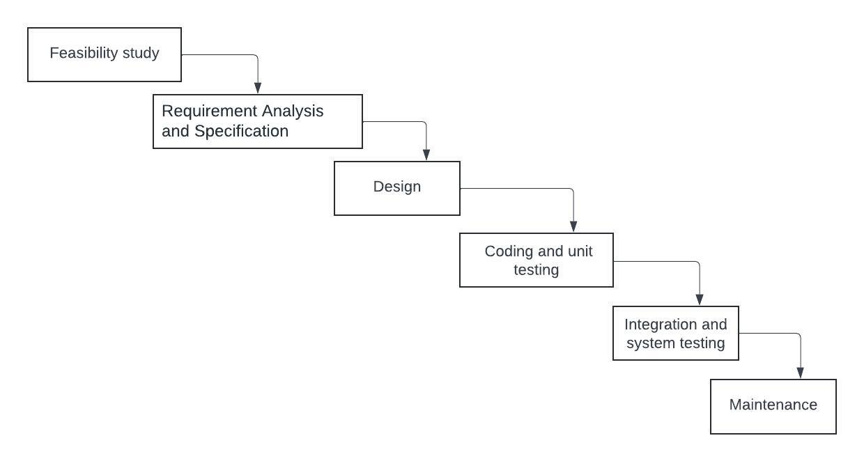

Figure 3.4.1: Waterfall Model

# CHAPTER 4: SYSTEM DESIGN

## 4.1 SYSTEM ARCHITECTURE

System architecture is the foundational framework that underpins the design and organization of complex systems, providing a structured blueprint for their development and operation. At its core, system architecture delineates the arrangement of components, modules, and interactions within a system, shaping its functionality, scalability, and reliability. It encompasses various aspects, including the identification of components, specification of interfaces, and definition of communication protocols.

Additionally, system architecture addresses scalability, flexibility, and performance considerations, anticipating future growth and technological advancements. Security and compliance are also integral components, ensuring data protection and regulatory adherence. Through meticulous planning, documentation, and governance, system architecture enables the creation of robust, adaptable, and secure systems that meet the evolving needs of users and organizations.

It serves as a guiding framework for developers, administrators, and stakeholders, facilitating effective collaboration and decision-making throughout the system's lifecycle. Overall, system architecture plays a pivotal role in driving innovation, efficiency, and competitiveness in today's dynamic technological landscape.

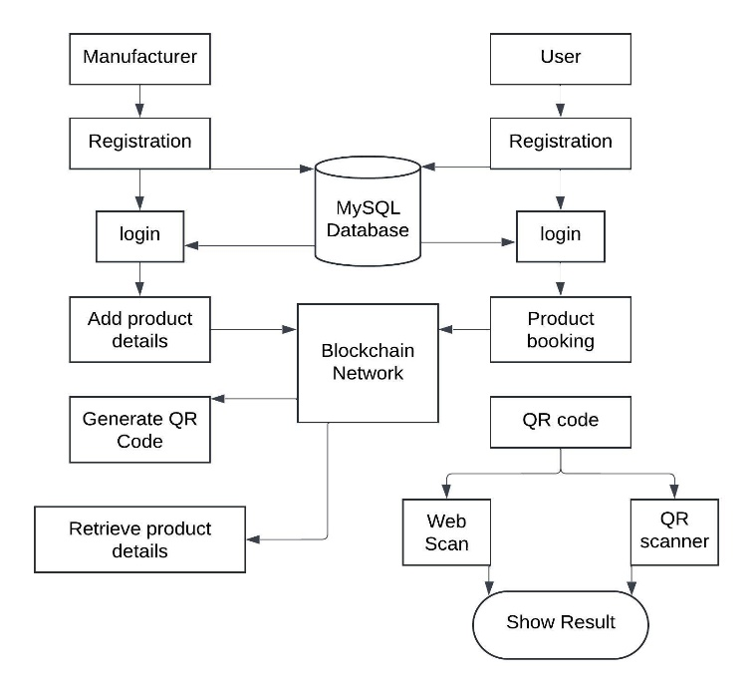

Figure 4.1.1: System Architecture

## 4.2 DATA FLOW DIAGRAM

The bubble chart represents each DFD call in turn. It’s far a sincere graphical formalism that can be used to depict a gadget in phrases of the information it is moreover fed into it, the diverse techniques which is probably completed on it, and the facts this is produced because of those operations. DFD illustrates how the records’ move around the system and how various changes affect them. It is a visual tool that indicates how facts flows and how statistics is converted because it actions from enter to output.

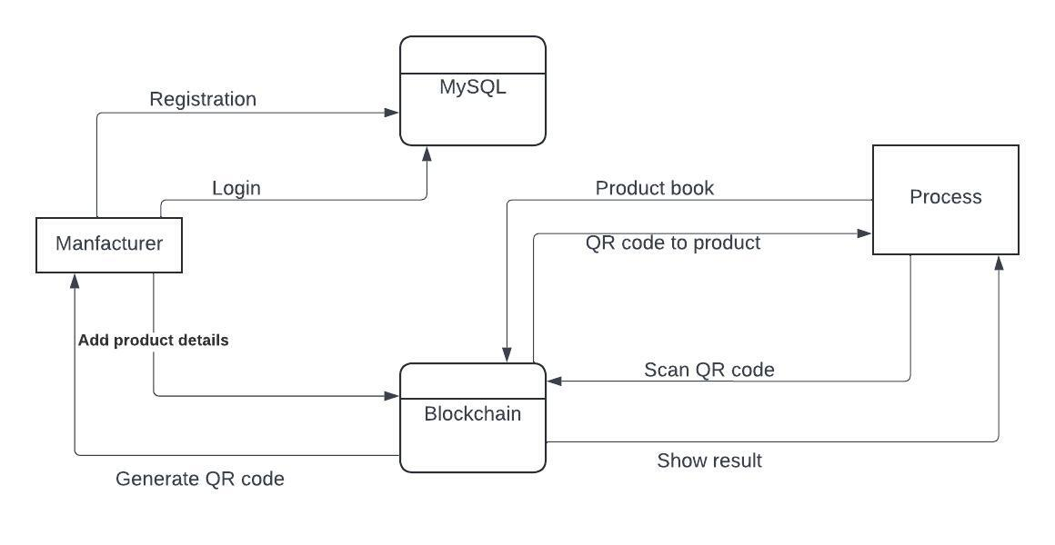

Figure 4.2.1: Data Flow Diagram

## 4.3 FLOW CHART

Flowcharts are indispensable visual aids utilized across diverse fields to depict the flow of processes, procedures, or algorithms. Serving as comprehensive blueprints, they simplify complex workflows into sequential steps, decision points, and actions, fostering clear understanding and effective communication. Comprising various symbols such as start and end points, process steps, decision points, and connectors, flowcharts encapsulate the logical progression of tasks within a system or process. They come in various types tailored to specific needs, including basic flowcharts, data flow diagrams, swimlane flowcharts, workflow diagrams, and UML activity diagrams. These visual representations offer myriad benefits, including simplifying comprehension, facilitating communication with stakeholders, identifying inefficiencies for optimization, and documenting standard operating procedures. Flowcharts can be crafted using specialized software or drawn manually, making them accessible and versatile tools for process management, problem-solving, and decision-making in industries ranging from software development and engineering to business management and education.

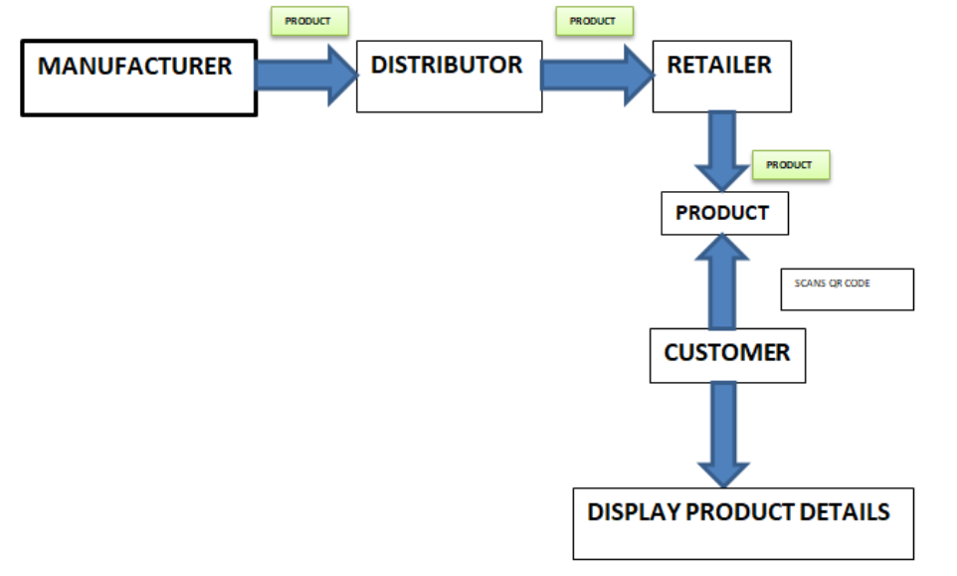

Figure 4.3.1: Flow Chart

## 4.4 BLOCK DIAGRAM

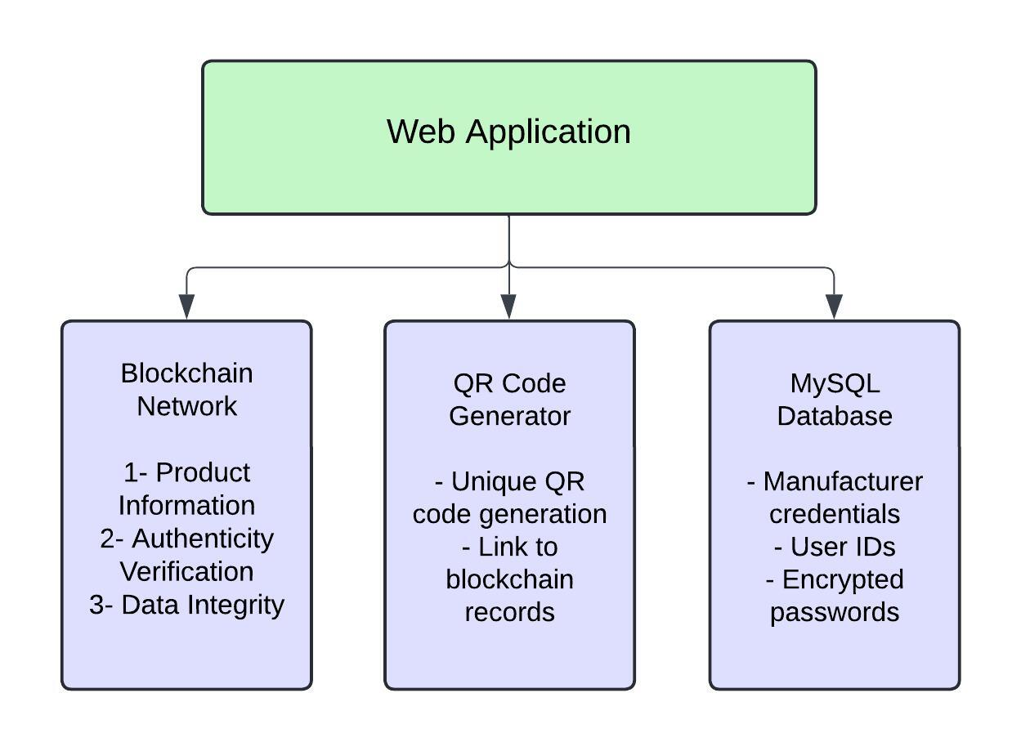

Figure 4.4.1: Block Diagram

## 4.5 USE CASE DIAGRAM

In the Unified Modeling Language (UML), a use case diagram is a particular type of behavioral graph that is derived from and defined using use-case analysis. Its goal is to graphically describe the actors in an assignment, their wishes (expressed as use instances), and any dependencies between those use cases. Determining whether or not a specific actor's movements are completed by using the tool is the primary goal of a use case diagram. Actor representations from the machine can have responsibilities.

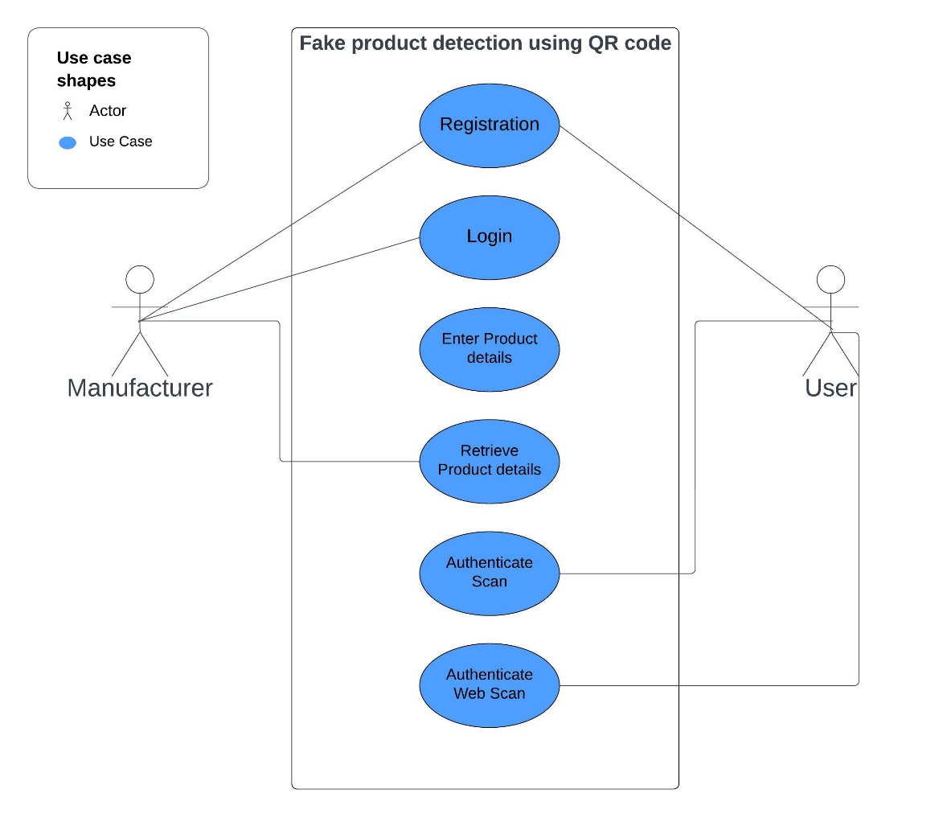

Figure 4.5.1: Use Case Diagram

## 4.6 SEQUENCE DIAGRAM

Sequence diagrams are invaluable tools used in software engineering and system design to visually represent the interactions between objects or components within a system over time. These diagrams provide a dynamic view of the system's behavior, illustrating the sequence of messages exchanged between various entities during the execution of a particular scenario or use case.

At their core, sequence diagrams consist of lifelines, representing the participating objects or actors, and messages, indicating the communication and interactions between these entities. Lifelines extend vertically across the diagram, depicting the lifespan of each object, while messages are depicted as arrows between lifelines, denoting the flow of control or data between them.

Sequence diagrams offer several advantages in system design and analysis. They facilitate the visualization and comprehension of complex system behaviors, helping stakeholders identify potential bottlenecks, inconsistencies, or ambiguities in the system's operation. Additionally, sequence diagrams serve as effective communication tools, enabling developers, designers, and stakeholders to collaborate and refine system requirements, design specifications, and implementation details.

Furthermore, sequence diagrams are not limited to software development but find applications in various domains, including business process modeling, system architecture design, and protocol specification. They provide a standardized and intuitive means of documenting system behaviors and interactions, enhancing communication and understanding among project stakeholders.

Creating sequence diagrams typically involves specialized modeling tools or software, such as Unified Modeling Language (UML) modeling tools or diagramming software like Microsoft Visio or Lucidchart. These tools offer features for easily creating, editing, and sharing sequence diagrams, facilitating collaboration and iteration throughout the software development lifecycle.

In summary, sequence diagrams play a vital role in system design and analysis by visually representing the dynamic interactions between objects or components within a system. They serve as powerful communication and documentation tools, aiding in requirements analysis, design specification, and implementation planning across various domains and industries.

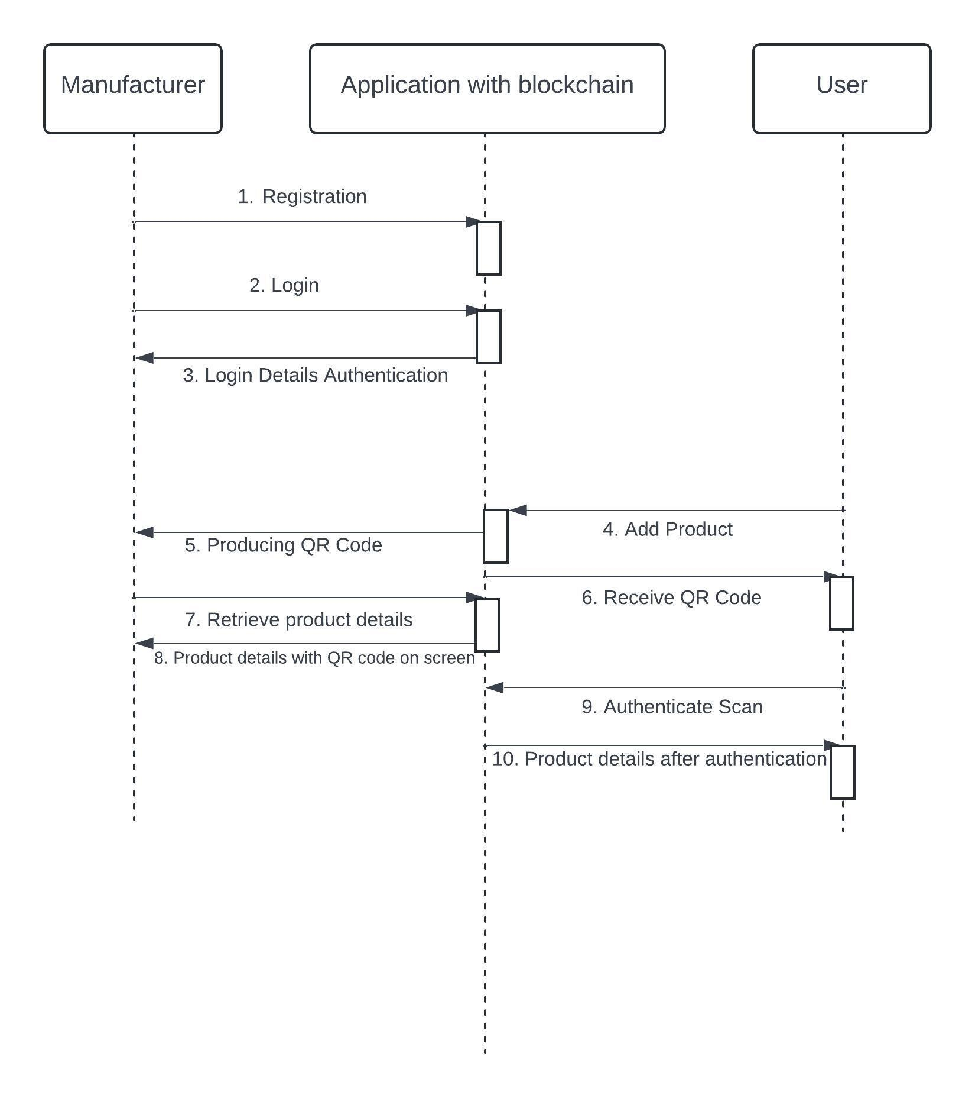

Figure 4.6.1: Sequence Diagram

# CHAPTER 5: PROJECT PLAN

## 5.1 PROJECT ESTIMATE

**5.1.1 Time Estimate**

|  |  |  |
| --- | --- | --- |
| **Sr. No.** | **Estimates** | **Time Taken (in Months)** |
| 1 | Literature Survey | 2 |
| 2 | Design | 1 |
| 3 | Powerpoint Presentation | 1 |
| 4 | Coding | 3 |
| 5 | Testing | 1 |
| 6 | Report | 1 |
| 7 | Total | 9 |

Table No.5.1.1. Time Estimate

## 5.2 RISK MANAGEMENT

Risk management encompasses the systematic process of identifying, evaluating, and mitigating potential threats that could impact an organization's financial well-being and profitability. These risks may stem from diverse sources, including financial instability, legal obligations, strategic management errors, accidents, and natural disasters. With the advent of the digital age, businesses are increasingly prioritizing the management of IT security threats and data-related risks. As a result, modern risk management plans now integrate measures to identify and address threats to digital assets. This includes safeguarding proprietary corporate data, securing customers' personally identifiable information, and preserving intellectual property. By proactively managing risks in the digital realm, organizations can enhance their resilience and safeguard their assets in an ever-evolving landscape.

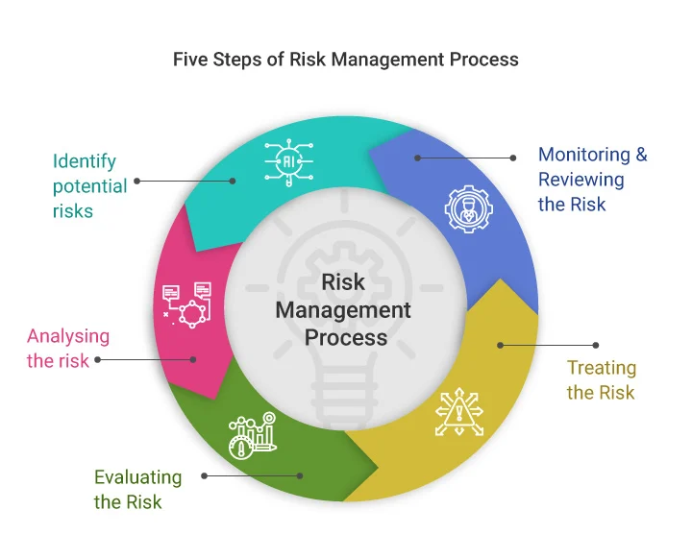

Figure 5.2.1. Risk Management

**5.2.1 Risk Identification**

Risk identification involves compiling a comprehensive list of potential risks associated with a project and detailing their characteristics. The outcomes of this process are typically documented in a risk register, which includes identified risks, their sources, potential responses, and categorization based on risk types. This information forms the basis for risk analysis and the development of effective risk response strategies. Risks can also be organized using a risk breakdown structure, a hierarchical framework classifying project risks by their sources.

While primarily conducted at the project's outset, risk identification is an iterative process. Throughout the project life cycle, new risks may arise due to internal or external factors, necessitating ongoing vigilance in identifying and addressing potential risks.

**5.2.1 Risk Analysis**

Risk analysis entails evaluating potential events or circumstances that could negatively impact a project, potentially hindering its successful and timely completion. It is crucial to anticipate and identify various risks to which a project may be vulnerable. This proactive approach enables the development of contingency plans to mitigate the consequences of each risk. Risk management aims to address all types of risks that could affect a project, encompassing uncertainties and potential losses associated with each risk. During risk analysis, we assess the level of uncertainty and potential loss, considering different categories of risks under consideration.

**5.2.1 Types of Risk**

1. Project Risks: Project risks threaten the Project Plan, potentially leading to schedule delays and increased costs upon materialization. These risks span various aspects including budget, schedule, personnel, resources, customers, and requirements, impacting software projects. To address project risks, we have adopted an iterative software development model.
2. Technical Risks: Technical risks jeopardize the quality and timely delivery of the software under development. They may render the implementation process challenging or even unattainable. Within our system, technical risks encompass potential issues related to design, implementation, integration, maintenance, and verification of the software.

## 5.3 PROJECT SCHEDULE

**5.3.1 Project Task Set:**

T1. Research fake product detection methods.

T2. Define project objectives and requirements.

T3. Design system architecture.

T4. Develop QR code generation and scanning.

T5. Implement blockchain for product verification.

T6. Integrate QR code scanning with blockchain.

T7. Develop user-friendly interface.

T8. Test and evaluate system functionality.

T9. Deploy, monitor, and support the system.

**5.3.2 Task Network:**

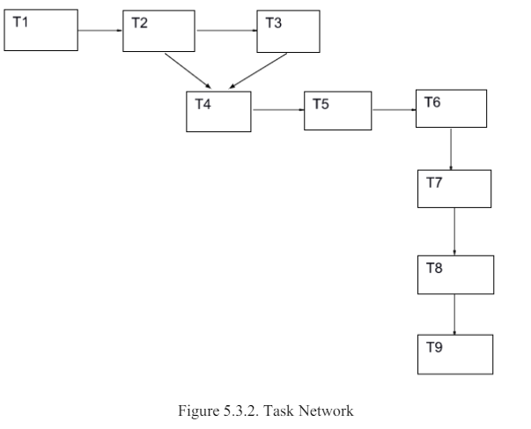

Figure 5.3.1. Task Network

**5.3.3 Timeline Chart:**

|  |  |  |  |  |  |  |  |  |  |  |  |
| --- | --- | --- | --- | --- | --- | --- | --- | --- | --- | --- | --- |
| **Sr No.** | **Task** | **2/11/23** | **8/11/23** | **1/1/23** | **7/1/24** | **15/1/24** | **20/1/24** | **25/3/24** | **10/4/24** | **16/4/24** | **24/4/24** |
| **1** | Research Fake Product detection methods |  |  |  |  |  |  |  |  |  |  |
| **2** | Define project objectives and requirements |  |  |  |  |  |  |  |  |  |  |
| **3** | Design system architecture |  |  |  |  |  |  |  |  |  |  |
| **4** | Develop QR code generation and scanning |  |  |  |  |  |  |  |  |  |  |
| **5** | Implement blockchain for product verification |  |  |  |  |  |  |  |  |  |  |
| **6** | Integrate QR code scanning with blockchain |  |  |  |  |  |  |  |  |  |  |
| **7** | Develop user-friendly interface |  |  |  |  |  |  |  |  |  |  |
| **8** | Test and evaluate system functionality |  |  |  |  |  |  |  |  |  |  |
| **9** | Deploy, monitor, and support the system. |  |  |  |  |  |  |  |  |  |  |

Table 5.3.3: Timeline Chart

**5.3.4 Team Organization:**

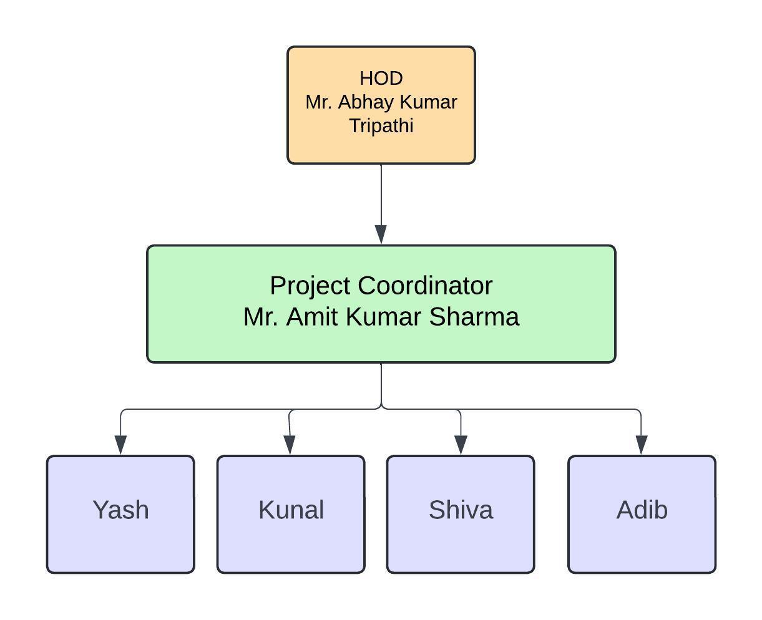

Figure 5.3.4: Team Organization

# CHAPTER 6: SYSTEM IMPLEMENTATION

## 6.1 INTRODUCTION

Fake products present a significant challenge across industries like fashion, electronics, pharmaceuticals, and luxury goods, posing threats to brand reputation and consumer safety. Implementing a fake product detection system utilizing blockchain technology offers transparency, traceability, and trust in supply chains.

Blockchain, a decentralized and immutable ledger, records transactions across multiple computers, providing features ideal for counterfeit detection. These include immutability, transparency, consensus, and cryptographic security. Leveraging these capabilities, a blockchain-based solution verifies product authenticity and provenance, empowering consumers to make informed choices and reducing the risk of purchasing counterfeit goods.

Here's how the system works:

1. Product Registration: Genuine products are registered on the blockchain, each assigned a unique identifier or digital signature. Manufacturer details, production date, and batch numbers are stored alongside.

2. Verification Mechanism: Consumers and stakeholders verify a product's authenticity by scanning its unique identifier or QR code via a web interface. The system retrieves relevant information from the blockchain and conducts cryptographic verification to ensure data integrity.

3. Anti-Counterfeit Measures: Additional security measures can be integrated, such as tamper-evident packaging, NFC tags, holographic labels, or unique identifiers embedded within the product. These physical features link to digital records on the blockchain, adding an extra layer of protection against counterfeiting.

By combining blockchain technology with anti-counterfeit measures, the system strengthens supply chain security, instills consumer confidence, and mitigates the risks associated with counterfeit products.

## 6.2 TOOLS AND TECHNOLOGY USED

1. Operating System: Windows 7 or above
2. Coding Language: Python 3.7
3. System: MINIMUM i3.
4. Hard Disk: 40 GB.
5. Ram: 4 GB.
6. GUI Applications (Tkinter)
7. Image processing (OpenCV, pillow)
8. XAMPP Local server
9. MySQL database

## 6.3 METHODOLOGY

This project comprises two distinct modules:

1. Manufacturer
2. Consumer/User.

Upon logging in, the Manufacturer module allows manufacturers to input product data such as product ID, name, and company name. This information is then stored in blocks within the system. Utilizing the SHA-256 algorithm, a hash code is generated for this information. Subsequently, this hash code is used to create a QR code, which is then printed on the merchandise.

The Consumer/User module comes into play when a user purchases a product. Upon purchase, the user receives the QR code associated with the product. Using either a web camera or a QR-code scanner, the user scans this QR code. The system then generates a hash code based on the scanned information.

The blockchain consisting, information about the transactional data of the products, can be interacted with using both the Manufacture and Customer modules.

A comparison is then made between the hash code generated from the scanned information and the hash code stored within the blockchain. If the two hash codes match, the product is deemed authentic, and the consumer is presented with the product data. Conversely, if there is a mismatch between the hash codes, the system identifies the product as counterfeit.

This process not only verifies the authenticity of the product but also provides crucial information regarding any tampering with the product and holds the accountable party responsible.

Our project is developed using Python for scripting, Tkinter for the user interface, a MySQL database for data storage, and XAMPP as the local server environment. In implementing the blockchain aspect, we followed a structured approach:

1. We opted to store information in JSON format due to its simplicity and readability. Each piece of data is encapsulated within a block, and multiple copies of this data reside within each block. To differentiate between blocks, we utilize fingerprinting techniques.
2. To ensure data integrity, we employ hash functions, particularly SHA256, which generates a unique hash for each block. This hash serves as a digital signature, making it computationally infeasible to tamper with the data.
3. Each block's hash also includes the hash of the preceding block, creating a chain-like structure. This linkage ensures the immutability of data within the blockchain, as altering one block would necessitate changing subsequent blocks, thereby maintaining the integrity of the entire chain.

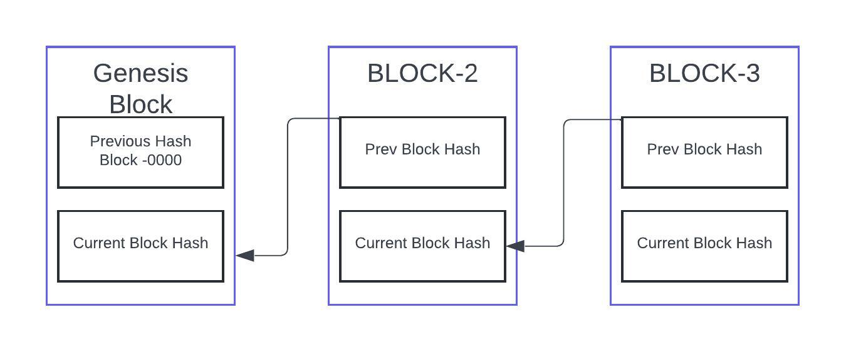

Figure 6.3.1: Chaining of Blocks in Blockchain

The proof of work method is integrated, significantly increasing the complexity of creating and adding new blocks to the chain. Any attempt to modify a previous block requires the perpetrator to redo the work associated not only with that block but also with all subsequent blocks in the chain. Moreover, the difficulty level for creating blocks can be further heightened to enhance security measures.

|  |  |  |
| --- | --- | --- |
| Product Name | Product ID | Hash Address |
| Balenciaga | 254798 | 0x5B38Da6a701c568545dCfcB03fEb870f56beddC4 |
| Gucci | 995752 | 0x3J38Da665401c568545dCfcB03fEb878351Ie1HC4 |
| Dolce & Gabanna | 741159 | 0x1C18DU6a701b568545rCfcB03fEb875F53hRdDk7 |

Table No.6.3.1. Product Data Table

## 6.4 ALGORITHM

**SHA-256 ALGORITHM**

1. SHA-256, a cryptographic hash algorithm, takes an input of any size and generates a fixed-size output of 256 bits.
2. SHA-256 is utilized to produce a unique hash for each block within the chain.
3. It ensures data integrity and authenticity in various cryptographic applications, including digital signatures, message authentication codes (MACs), and checksums.
4. It operates as a one-way hash function, making it computationally infeasible to reverse the process and retrieve the original input data from the hash value.
5. It consists of logical operations such as bitwise operations (AND, OR, XOR), modular addition, and circular shifts.
6. These operations are applied in multiple rounds to the input data to generate the final hash value.
7. It is designed to be resistant to cryptographic attacks, including collision attacks and preimage attacks.
8. It relies on the cryptographic properties of its underlying operations and the complexity of its design for security.
9. It is Widely used in digital certificates, SSL/TLS protocols, cryptocurrency (e.g., Bitcoin), password hashing algorithms (e.g., bcrypt, PBKDF2), and integrity verification mechanisms (e.g., digital signatures).
10. It is implemented as a software library or a hardware accelerator for improved performance.

Steps:

1. The SHA-256 algorithm is used in blockchain to generate a constant hash of 256 bits.

2. The algorithm uses an initial value (IV) of 256 bits and breaks down large input into blocks of 512 bits.

3. Any remaining input is padded with additional bits to make it a multiple of 512 bits.

4. The 512-bit input is then combined with the 256-bit IV to create a total of 768 bits.

5. The 768 bits are then compressed using a specific function to produce an output of only 256 bits.

6. This output is then merged with the next 512-bit input from the next block.

7. The process is repeated for each block until all input has been processed.

8. The final output is a 256-bit hash of the input data.

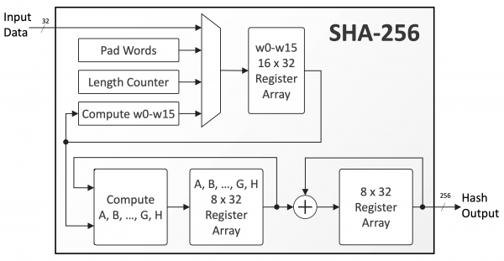

Figure 6.4.1: SHA-256 Working

**MD5 ALGORITHM**

1. MD5, which stands for Message Digest Algorithm 5, is a widely used cryptographic hash function.
2. It was designed by Ronald Rivest in 1991 as an improvement over earlier hash functions like MD4.
3. MD5 is commonly used in various applications, including digital signatures, password hashing, and checksums.

1. Hash Function:

1. MD5 operates as a one-way hash function, generating a fixed-size hash value (128 bits) from input data of arbitrary size.
2. It produces a unique hash value for each input, making it suitable for verifying data integrity and authenticity.

2. Structure:

1. MD5 processes input data in blocks of 512 bits and produces a 128-bit hash value as output.
2. The algorithm consists of several rounds of processing, where each round involves a series of logical operations and modular addition.
3. These operations include bitwise logical functions (AND, OR, XOR), modular addition, left rotation, and constant addition.

3. Security:

1. MD5 was once widely used for cryptographic purposes, but its security has been significantly compromised over the years.
2. Vulnerabilities such as collision attacks and pre-image attacks have been discovered, making it unsuitable for applications requiring strong security guarantees.
3. Collisions occur when two different inputs produce the same hash value, undermining the integrity of the hash function.

4. Usage:

1. Despite its security vulnerabilities, MD5 is still used in legacy systems and applications for tasks such as file checksums and digital signatures.
2. However, it is not recommended for new cryptographic applications due to its weaknesses.

5. Implementation:

1. Implementations of MD5 are available in various programming languages and libraries, making it accessible for developers.
2. It is typically implemented as a software library or a function call within programming environments.

6. Alternatives:

1. Due to its vulnerabilities, MD5 is often replaced by more secure hash functions such as SHA-256 and SHA-3 in modern applications.
2. These alternatives offer stronger security guarantees and resistance to known cryptographic attacks.

**BCRYPT ALGORITHM**

bcrypt is a cryptographic hashing function primarily used for securely storing passwords. It's designed to be slow and computationally intensive, which makes it resistant to brute-force attacks and rainbow table attacks, where attackers attempt to crack passwords by trying many possible combinations or precomputed hashes.

1. Security: bcrypt is considered a secure hashing algorithm due to its key properties, such as being resistant to brute-force attacks and precomputation attacks. Its slowness makes it computationally expensive for attackers to generate hashes for potential passwords.

2. Salted Hashes: bcrypt automatically generates and incorporates a random salt for each password hash. Salting adds additional randomness to each hashed password, preventing identical passwords from producing the same hash and mitigating against rainbow table attacks.

3. Adaptive Work Factor: bcrypt allows for the adjustment of its computational cost through a parameter called the "work factor" or "cost factor." This factor determines the number of iterations used in the hashing process, making it adaptable to hardware improvements and increasing its resistance to attacks over time.

4. Common Usage: bcrypt is widely used in web development frameworks and platforms for securely storing user passwords. It's a recommended choice for password hashing in programming languages like Python, PHP, and Ruby on Rails.

5. Considerations: While bcrypt is highly secure, it's essential to use it correctly within the context of a larger security framework. This includes securely managing and storing salt values, implementing proper password handling practices, and staying informed about any updates or vulnerabilities related to bcrypt implementations.

# CHAPTER 7: SOFTWARE TESTING

Software testing is a process, to evaluate the functionality of a software application with an intent to find whether the developed software met the specified requirements or not and to identify the defects to ensure that the product is defect free in order to produce the quality product.

## 7.1 TESTING APPROACHES

1. White Box Testing:

White Box Testing, also known as Clear Box Testing or Structural Testing, is a software testing method where testers evaluate the internal workings or code structure of the software under test. Testers have access to the source code and design documents to create test cases based on the internal logic of the application.

2. Black Box Testing:

Black Box Testing, also referred to as Behavioral or Specification-Based Input-Output Testing, is a software testing method where testers assess the functionality of the software without examining its internal code structure. Testers focus solely on the input and output of the software, testing against the specified requirements or behavior.

3. Grey Box Testing:

Grey Box Testing is a software testing technique that combines elements of both White Box and Black Box Testing. Testers have limited access to the internal workings of the software, such as access to the source code or design documents, but do not have full visibility. This allows testers to create test cases based on both internal logic and specified requirements.

For our system, we have chosen Black Box Testing for the following reasons:

- Unbiased testing: Testers and designers work independently, reducing bias in testing.

- No programming language knowledge required: Testers do not need knowledge of specific programming languages, enabling a wider pool of testers.

- Identification of contradictions: Black Box Testing facilitates the detection of inconsistencies and ambiguities in functional specifications.

- User's perspective: Tests are conducted from a user's perspective, ensuring that the software meets user requirements.

- Immediate test case design: Test cases can be created promptly after the completion of specifications, enhancing efficiency in the testing process.

## 7.2 TEST CASES AND RESULTS

|  |  |  |  |  |  |  |
| --- | --- | --- | --- | --- | --- | --- |
| Test ID | Test Case Summary | Prerequisites | Test Procedure | Expected Result | Actual Result | Status |
| 1 | Manufacturer Registration | Availability of details of required fields. | • Click on Manufacturer login  • Click on Registered New Account • Fill all the required fields  • Click on submit | Successfully registered | Successfully registered | Pass |
| 2 | Manufacturer Login | Availability of registered Email and Password | • Fill the Email and Password Field  • Click on Login | Welcome | Welcome | Pass |
| 3 | Product Registration | Availability of details of required fields | • Fill the Unique Product ID with its Product Name  • Fill up the company details.  • Click on Save Product with Blockchain | QR code is saved successfully! | QR code is saved successfully! | Pass |
| 4 | Retrieve Product Data | Availability of Product ID already registered | • Fill the Product ID  • Click on Retrieve Product Data | Product Details extracted from Blockchain using Product ID | Product Details extracted from Blockchain using Product ID | Pass |
| 5 | Authenticate Scan | Availability of QR generated image | • Click on Authenticate Scan  • A QR code generated image with Product id is saved.  • Select the QR generated image that is required to authenticate | Uploaded Product Barcode Authentication Successful with an output.html | Uploaded Product Barcode Authentication Successful with an output.html | Pass |

Table No.7.2.1 Test Cases and Results

# CHAPTER 8: RESULTS

## 8.1 SCREENSHOTS

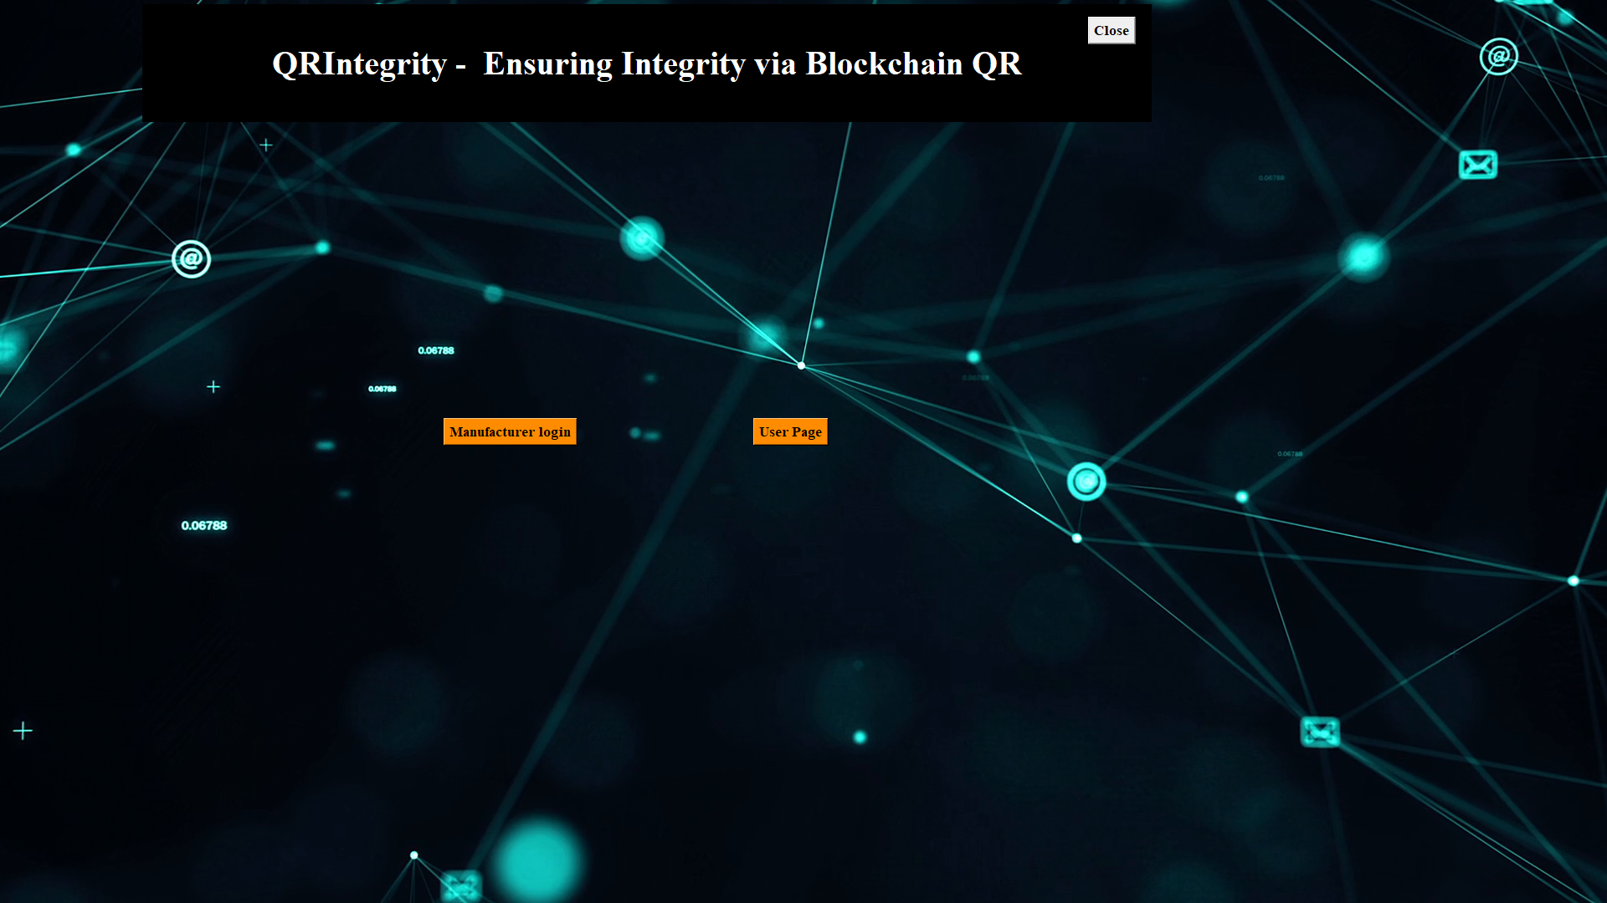

Figure.8.1.1. Home Page

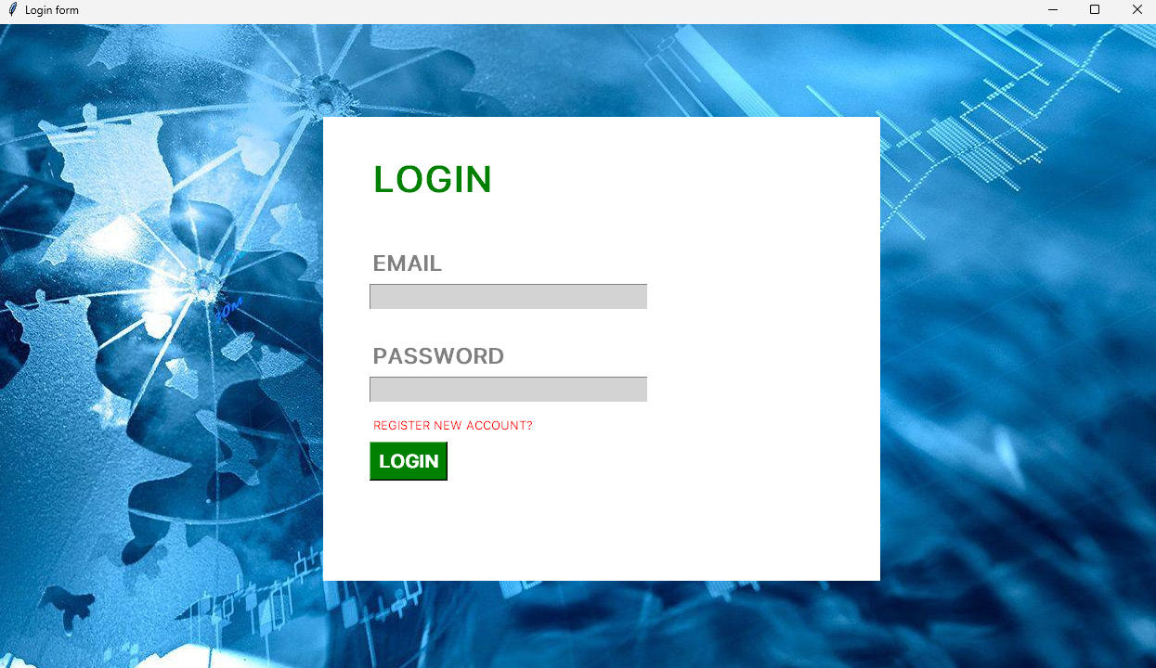

Figure.8.2.1. Login Page

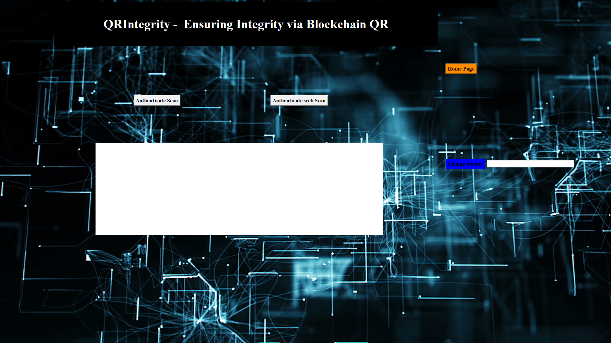

Figure.8.3.1. User Main

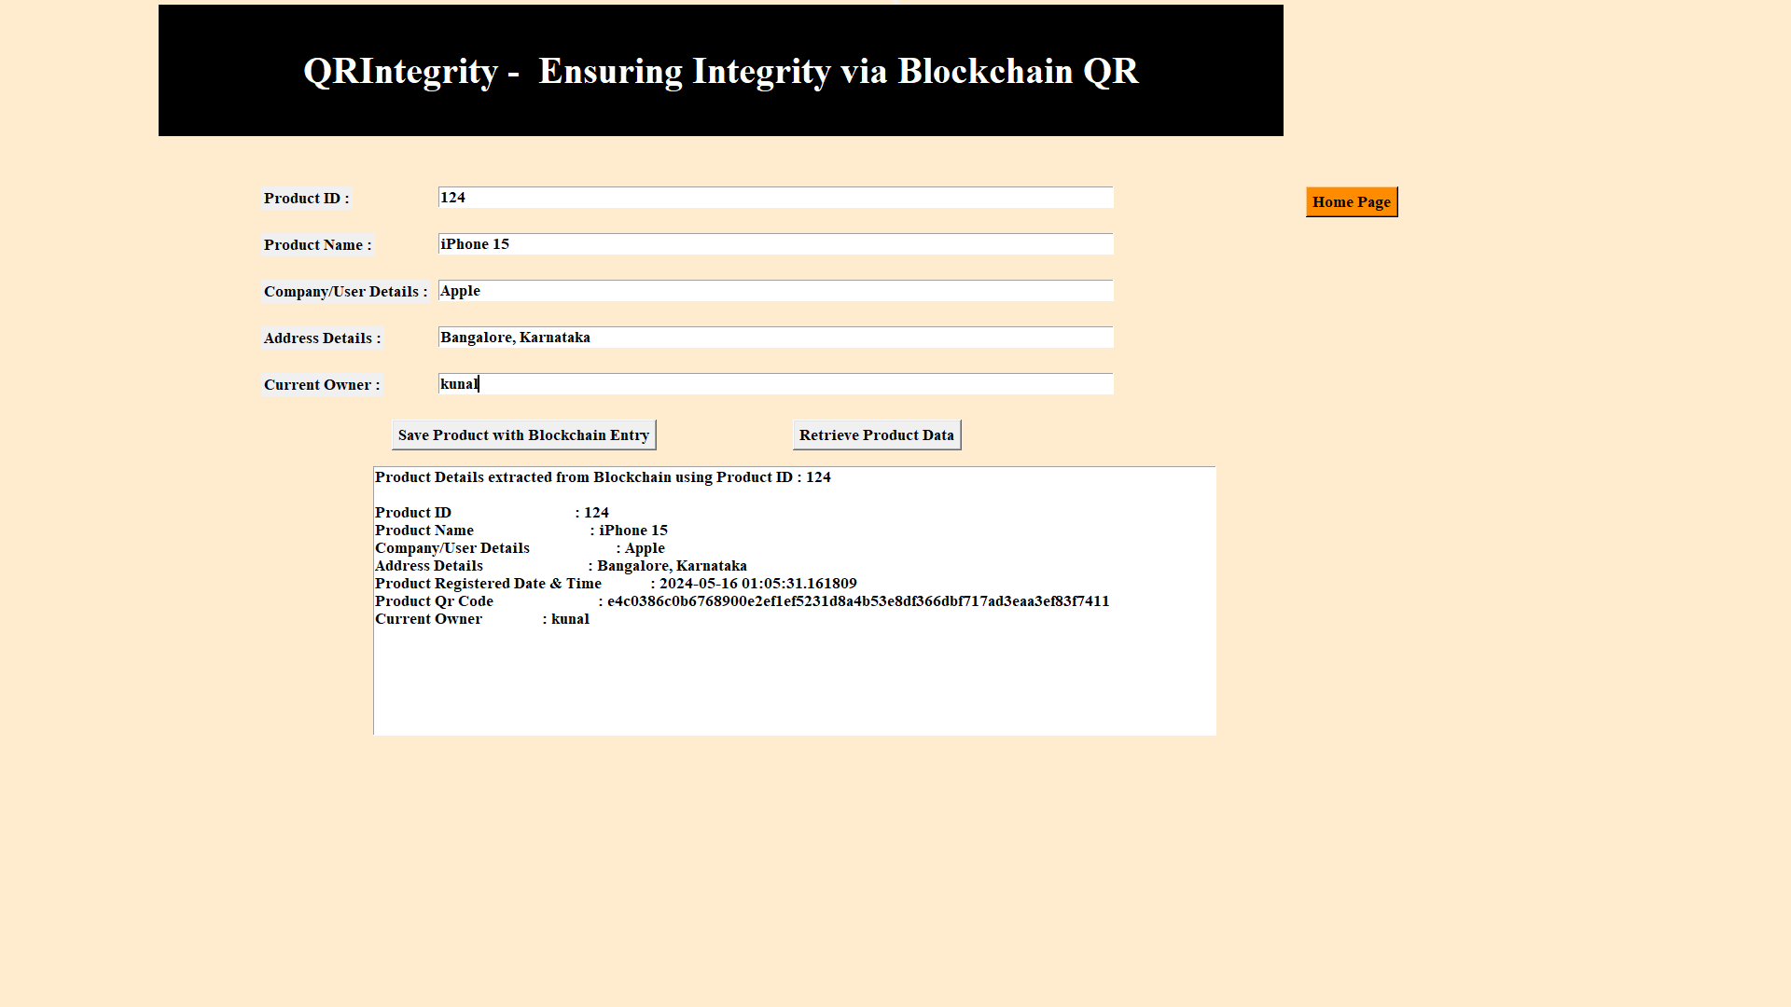

Figure.8.4.1. Validation Page

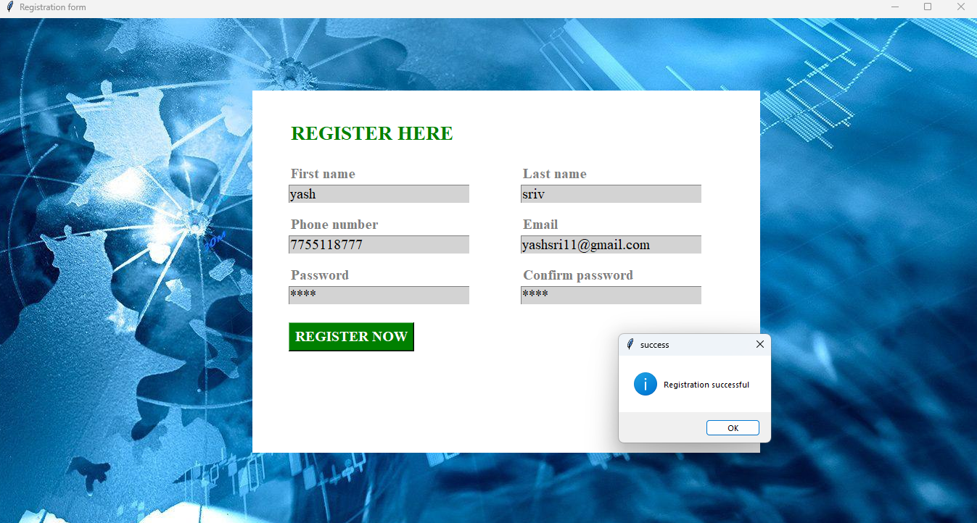

Figure.8.5.1. Registration Page

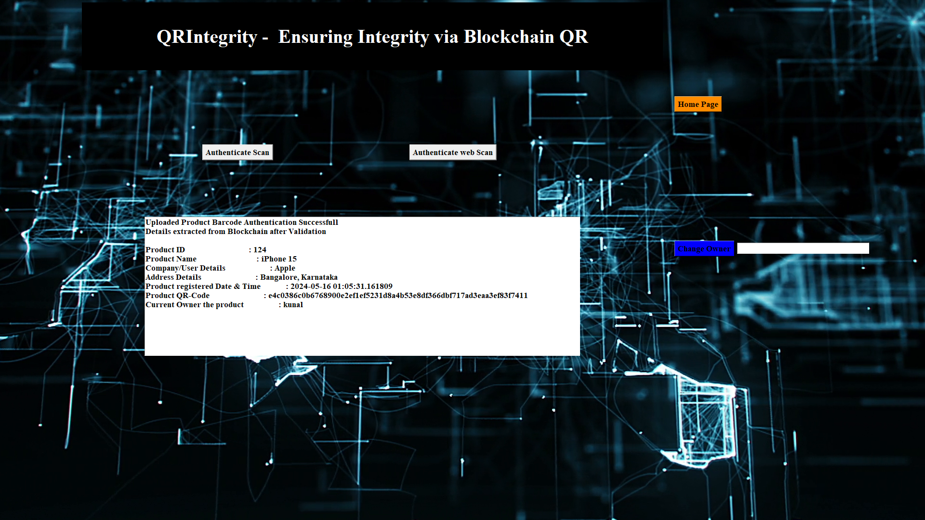

Figure.8.6.1. Product Authentication

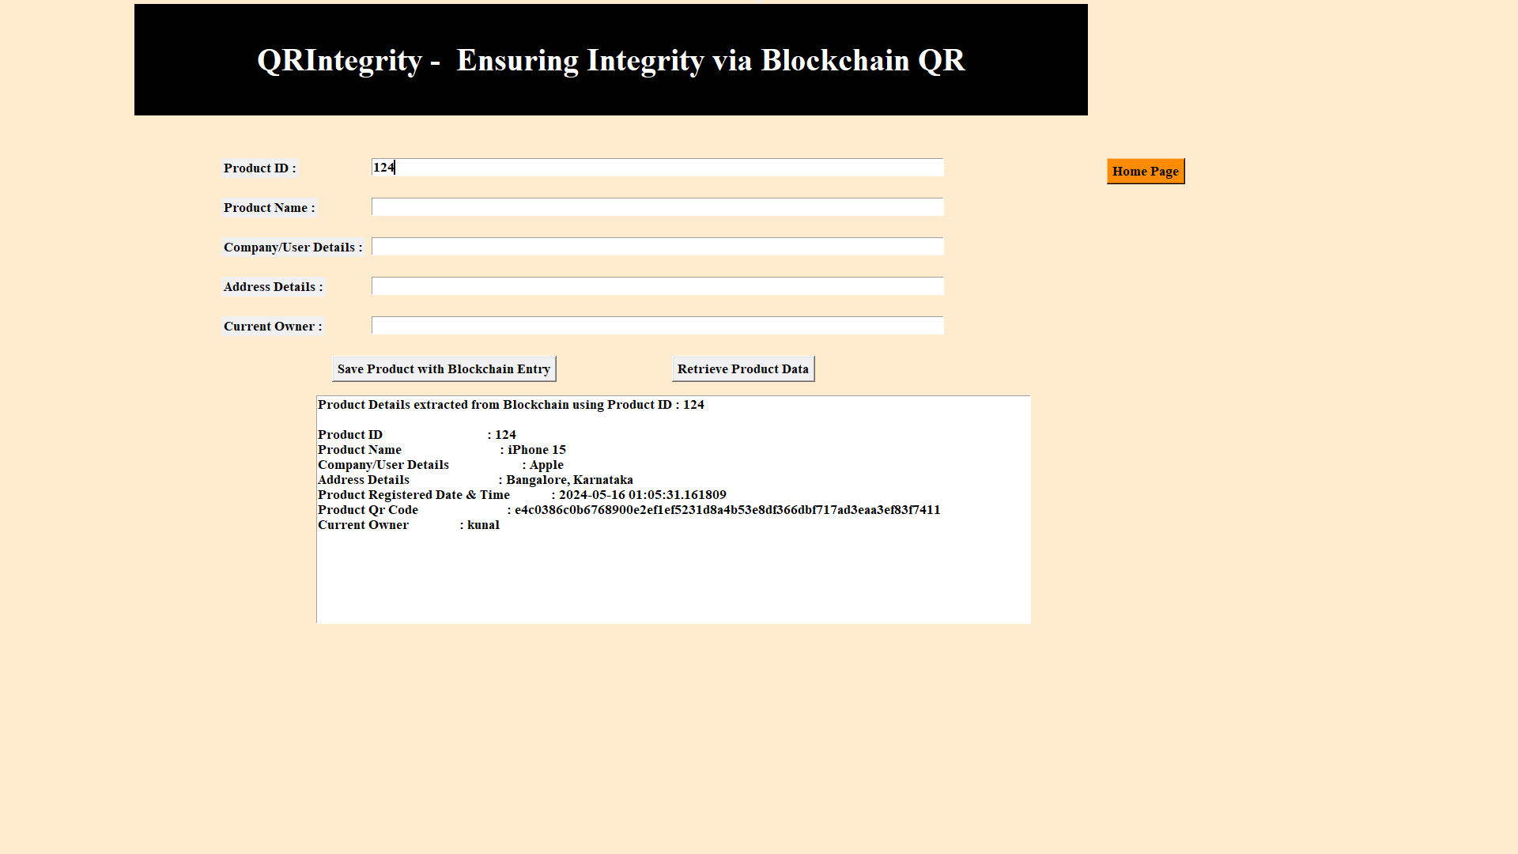

Figure.8.7.1. Product Retrieval

|  |  |  |  |  |  |  |
| --- | --- | --- | --- | --- | --- | --- |
| **Block No** | **ProductID** | **Product Name** | **Company/User Details** | **Address Details** | **Scan Date & Time** | **Product QR code** |
| 44 | 124 | iPhone15 | Apple | Bangalore | 2024-04-16 01:05:31 | e4c0386c0b6768900e2ef1ef5231d8a4b53e8df366dbf717ad3eaa3ef83f7411 |

Table.8.1.1 Output.html

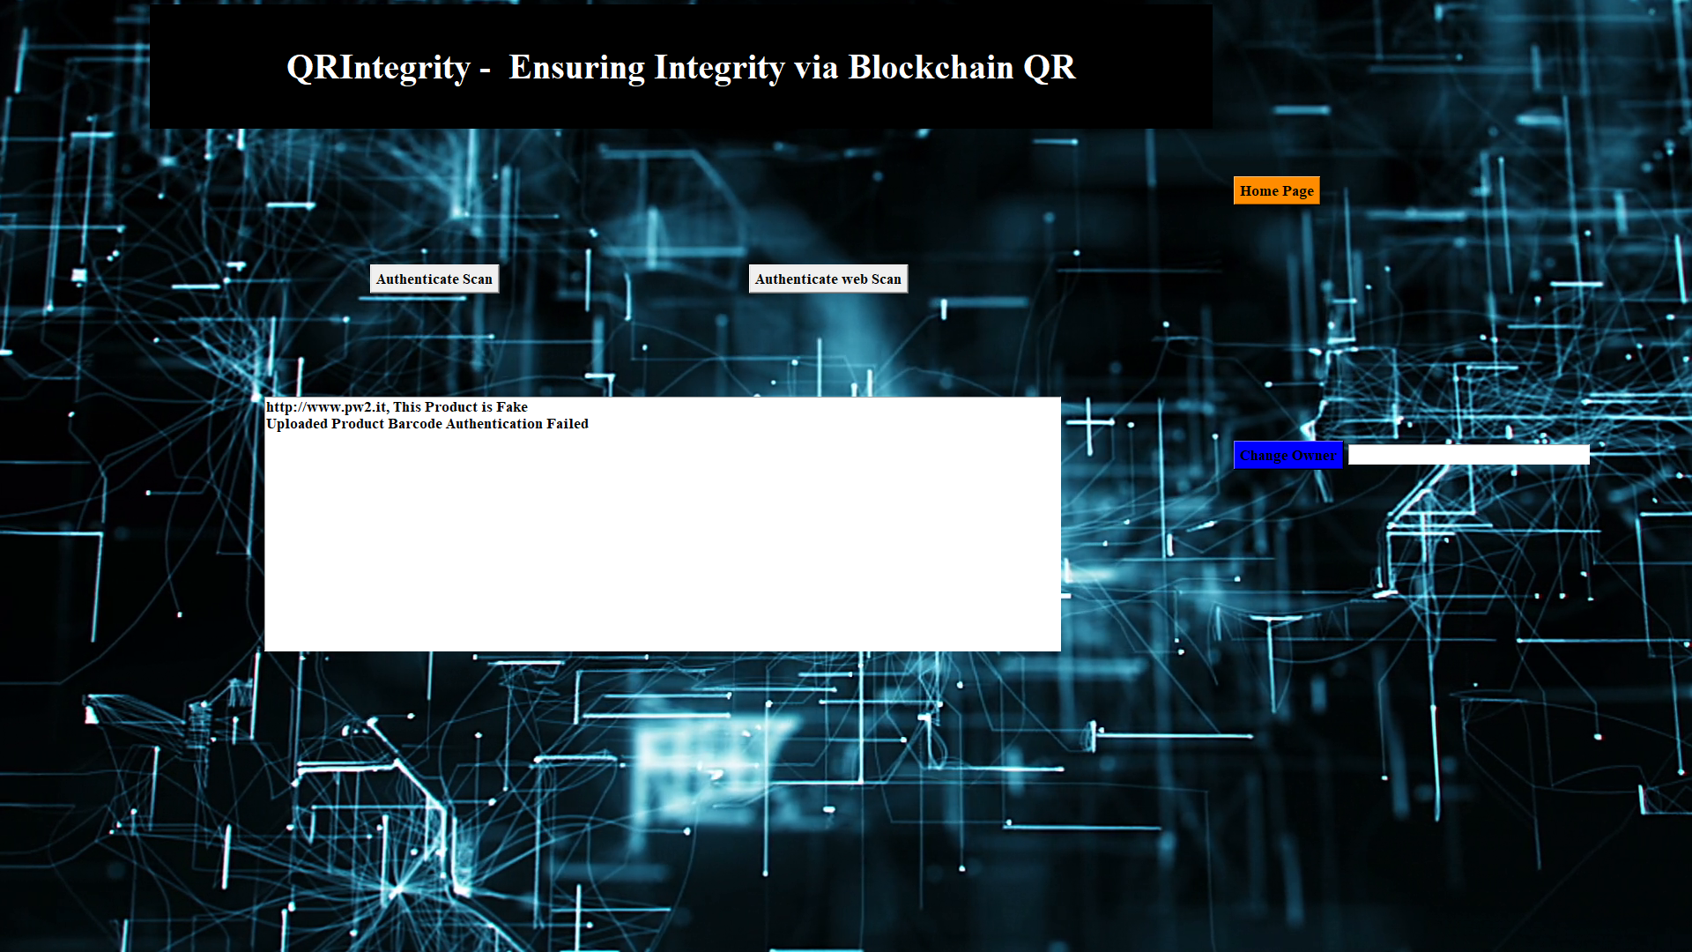

Figure.8.9.1. Product Authentication Failed



Figure.8.10.1. Generated QR Code

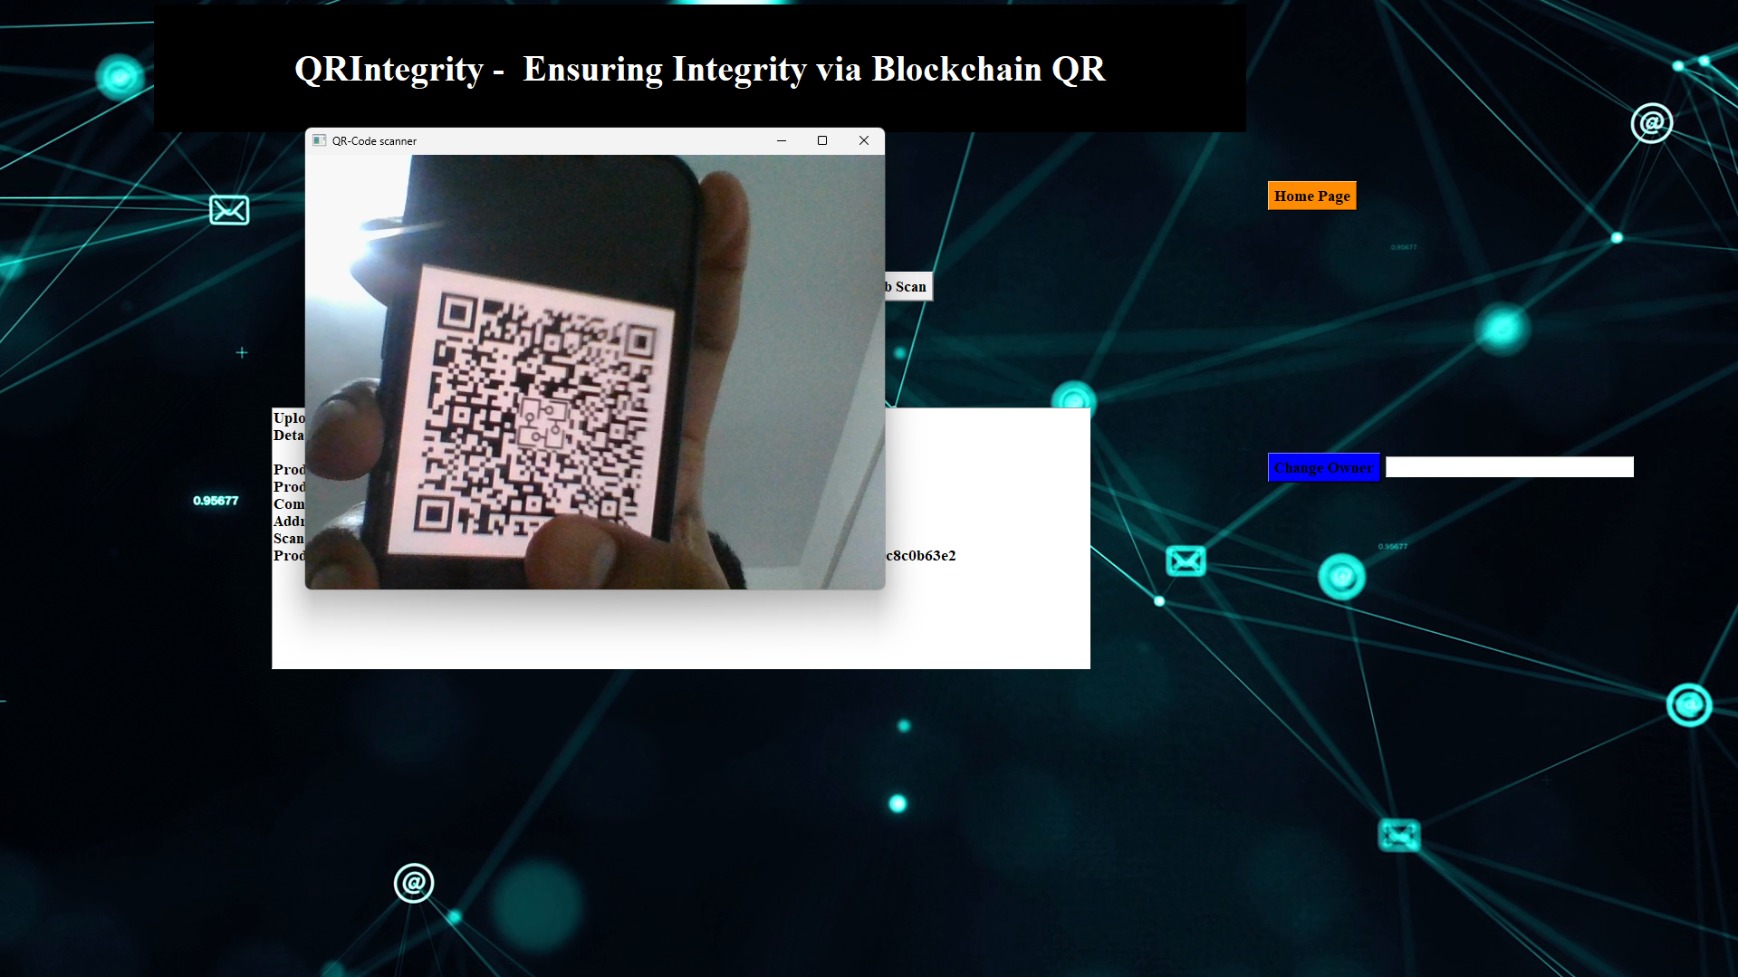Figure.8.11.1. Real Time QR Scan

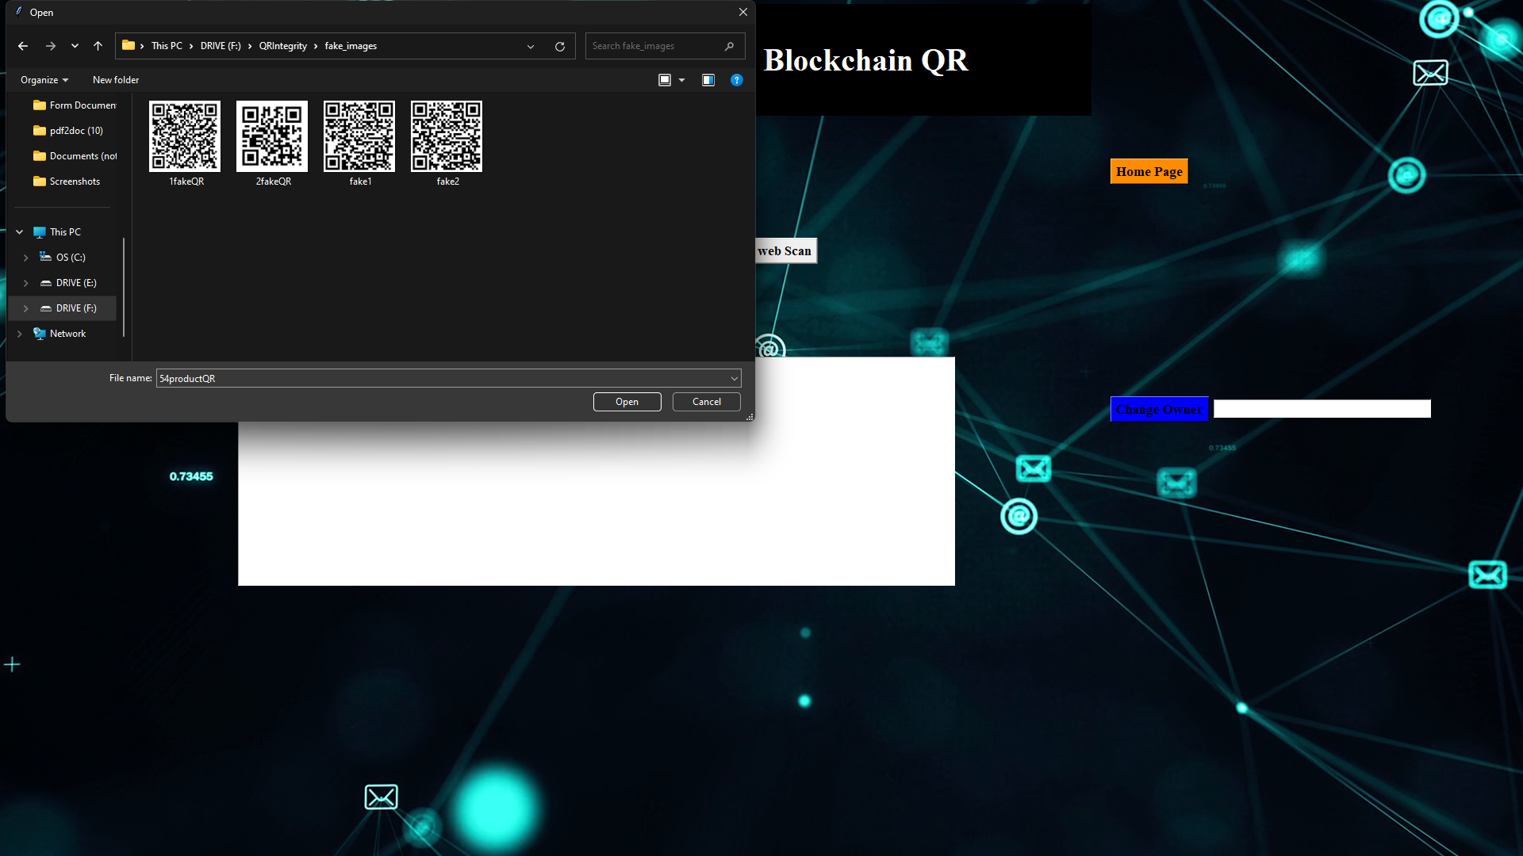Figure.8.12.1. Validating fake QR code

## 8.2 SOURCE CODE:

Libraries that we are using in the blockchain architecture:

First, we import all the libraries we will be needed in the system, the libraries that we will be using in the system are:

1. Block
2. Hashlib
3. Math
4. Qrcode
5. PIL
6. tkinter
7. cv2
8. image.io
9. Mysql
10. Pyzbar
11. threading
12. pickle
13. datetime
14. random
15. os

**Setup the Admin Page**

from tkinter import messagebox

from tkinter import *

# from tkinter import simpledialog

import tkinter

# from tkinter import filedialog

from tkinter.filedialog import askopenfilename

from Block import *

from Blockchain import *

from hashlib import sha256

import os

import datetime

import webbrowser

import qrcode

import random

import cv2

import sys

from PIL import ImageTk, Image

import PIL.Image

import imageio

import threading

import mysql

import mysql.connector

main = tkinter.Tk()

main.title("QRIntegrity - Ensuring Integrity via Blockchain QR")

main.attributes('-fullscreen', True)

#main.geometry('1300x1200')

video_name = "bg\\home.mp4" #This is your video file path

video = imageio.get_reader(video_name)

def stream(label):

for image in video.iter_data():

frame_image = ImageTk.PhotoImage(PIL.Image.fromarray(image))

label.config(image=frame_image)

label.image = frame_image

my_label = tkinter.Label(main)

my_label.pack()

thread = threading.Thread(target=stream, args=(my_label,))

thread.daemon = 1

thread.start()

**Addition of product details:**

blockchain = Blockchain()

if os.path.exists('blockchain_contract.txt'):

with open('blockchain_contract.txt', 'rb') as fileinput:

blockchain = pickle.load(fileinput)

fileinput.close()

def addProduct():

global filename

text.delete('1.0', END)

pid = tf1.get()

name = tf2.get()

user = tf3.get()

address = tf4.get()

currentowner = tf5.get()

con=mysql.connector.connect(host="localhost",user="root",password="notgu3ssabl3",database="reg1")

cur=con.cursor()

cur.execute("insert into curr_owner (pid, owner) values(%s,%s)",

(

pid,

currentowner

))

con.commit()

con.close()

rom=hex(random.getrandbits(128))

bytes=rom.encode('utf-8')

digital_signature = sha256(bytes).hexdigest();

global QRimg

logo = Image.open('bg\\logo.jpg')

basewidth = 100

wpercent = (basewidth/float(logo.size[0]))

hsize = int((float(logo.size[1]) * float(wpercent)))

logo = logo.resize((basewidth, hsize), Image.ANTIALIAS)

QRcode = qrcode.QRCode(error_correction=qrcode.constants.ERROR_CORRECT_H)

QRcode.add_data(digital_signature)

QRcode.make(fit=True)

QRimg = QRcode.make_image().convert('RGB')

pos = ((QRimg.size[0] - logo.size[0]) // 2, (QRimg.size[1] - logo.size[1]) // 2)

QRimg.paste(logo, pos)

QRimg.save('original_barcodes'+'\\'+str(pid)+'productQR.png')

if len(pid) > 0 and len(name) > 0 and len(user) > 0 and len(address) > 0:

current_time = datetime.datetime.now()

data = pid+"#"+name+"#"+user+"#"+address+"#"+str(current_time)+"#"+digital_signature

blockchain.add_new_transaction(data)

hash = blockchain.mine()

b = blockchain.chain[len(blockchain.chain)-1]

text.insert(END,"Blockchain Previous Hash : "+str(b.previous_hash)+"\n")

text.insert(END,"Block No : "+str(b.index)+"\n")

text.insert(END,"Product Qr-code no : "+str(digital_signature)+"\n")

blockchain.save_object(blockchain,'blockchain_contract.txt')

img2= Image.open('original_barcodes'+'\\'+str(pid)+'productQR.png')

load=img2.resize((200,200))

render = ImageTk.PhotoImage(load)

img = Label(main, image=render)

img.place(x=140, y=500)

tf1.delete(0, 'end')

tf2.delete(0, 'end')

tf3.delete(0, 'end')

tf4.delete(0, 'end')

messagebox.showinfo("QR Code Generator", "QR Code is saved successfully!")

else:

text.insert(END,"Please enter all details")

**Searching for product:**

def searchProduct():

text.delete('1.0', END)

pid = tf1.get()

flag = True

if len(pid) > 0:

for i in range(len(blockchain.chain)):

if i > 0:

b = blockchain.chain[i]

data = b.transactions[0]

arr = data.split("#")

if arr[0] == pid:

mydb = mysql.connector.connect(

host="localhost",

user="yash",

password="123456",

database="reg1"

)

mycursor = mydb.cursor()

# print(arr[0] + " here is the ")

mycursor.execute("SELECT owner FROM curr_owner where pid = %s", [arr[0]])

myresult = mycursor.fetchall()

global QRimg

logo = Image.open('bg\\logo.jpg')

basewidth = 100

wpercent = (basewidth/float(logo.size[0]))

hsize = int((float(logo.size[1]) * float(wpercent)))

logo = logo.resize((basewidth, hsize), Image.Resampling.LANCZOS)

QRcode = qrcode.QRCode(error_correction=qrcode.constants.ERROR_CORRECT_H)

QRcode.add_data(arr[5])

QRcode.make(fit=True)

QRimg = QRcode.make_image().convert('RGB')

pos = ((QRimg.size[0] - logo.size[0]) // 2, (QRimg.size[1] - logo.size[1]) // 2)

QRimg.paste(logo, pos)

QRimg.save('original_barcodes'+'\\'+str(pid)+'productQR.png')

output = ''

text.insert(END,"Product Details extracted from Blockchain using Product ID : "+pid+"\n\n")

text.insert(END,"Product ID : "+arr[0]+"\n")

text.insert(END,"Product Name : "+arr[1]+"\n")

text.insert(END,"Company/User Details : "+arr[2]+"\n")

text.insert(END,"Address Details : "+arr[3]+"\n")

text.insert(END,"Product Registered Date & Time : "+arr[4]+"\n")

text.insert(END,"Product Qr Code : "+arr[5]+"\n")

text.insert(END,"Current Owner : "+ str(myresult[0][0]))

output='<html><body><table border=1>'

output += '<tr><th>Block No</th><th>Product ID</th><th>Product Name</th><th>Company/User Details</th><th>Address Details</th><th>Scan Date & Time</th><th>Product Qr code</th></tr>'

output += '<tr><td>' + str(i) + '</td><td>' + arr[0] + '</td><td>' + arr[1] + '</td><td>' + arr[2] + '</td><td>' + arr[3] + '</td><td>' + arr[4] + '</td><td>' + arr[5] + '</td></tr>'

f = open("output.html", "w")

f.write(output)

f.close()

flag = False

img2= Image.open('original_barcodes'+'\\'+str(pid)+'productQR.png')

load=img2.resize((200,200))

render = ImageTk.PhotoImage(load)

img = Label(main, image=render)

img.place(x=140, y=500)

#messagebox.showinfo("", "Retrieve product QR-code!")

break

if flag:

text.insert(END,"Given product id does not exists")

**Implementation of Genesis Block:**

from hashlib import sha256

import json

import time

import pickle

from datetime import datetime

import random

import base64

from Block import *

class Blockchain:

difficulty = 2

# FIRST

def __init__(self):

self.unconfirmed_transactions = []

self.chain = []

self.create_genesis_block()

self.peer = []

self.translist = []

def create_genesis_block(self): #create genesis block

genesis_block = Block(0, [], time.time(), "0")

genesis_block.hash = genesis_block.compute_hash()

self.chain.append(genesis_block)

def last_block(self):

return self.chain[-1]

**Implementation of Blocks using Proof of Work concept:**

def proof_of_work(self, block): #proof of work

block.nonce = 0

computed_hash = block.compute_hash()

while not computed_hash.startswith('0' * Blockchain.difficulty):

block.nonce += 1

computed_hash = block.compute_hash()

return computed_hash

# THREE

def add_block(self, block, proof): #adding data to block by computing new and previous hashes

previous_hash = self.last_block.hash

if previous_hash != block.previous_hash:

return False

if not self.is_valid_proof(block, proof):

return False

block.hash = proof

self.chain.append(block)

return True

def is_valid_proof(self, block, block_hash): #proof of work

return (block_hash.startswith('0' * Blockchain.difficulty) and block_hash == block.compute_hash())

def add_new_transaction(self, transaction):

self.unconfirmed_transactions.append(transaction)

def addPeer(self, peer_details):

self.peer.append(peer_details)

def addTransaction(self,trans_details): #add transaction

self.translist.append(trans_details)

def mine(self):

if not self.unconfirmed_transactions:

return False

last_block = self.last_block

new_block = Block(index=last_block.index + 1,

transactions=self.unconfirmed_transactions,

timestamp=time.time(),

previous_hash=last_block.hash)

proof = self.proof_of_work(new_block)

self.add_block(new_block, proof)

self.unconfirmed_transactions = []

return new_block.index

def save_object(self,obj, filename):

with open(filename, 'wb') as output:

pickle.dump(obj, output, pickle.HIGHEST_PROTOCOL)

**User Access Page Code:**

from tkinter import messagebox

from tkinter import *

from tkinter import simpledialog

import tkinter

from tkinter import filedialog

from tkinter.filedialog import askopenfilename

from Block import *

from Blockchain import *

from hashlib import sha256

import os

import datetime

import webbrowser

import qrcode

import random

import cv2

import sys

import PIL.Image

from PIL import ImageTk, Image

import PIL.Image

import imageio

import threading

import qrtools

from PIL import Image

#from pyzbar.pyzbar import decode

import pyzbar.pyzbar as pyzbar

import mysql.connector

main = Tk()

main.title("QRIntegrity - Ensuring Integrity via Blockchain QR")

main.attributes('-fullscreen', True)

#main.geometry('1300x1200')

ifQRSCANNED=[]

video_name = "bg\\home.mp4"

video = imageio.get_reader(video_name)

def stream(label):

for image in video.iter_data():

frame_image = ImageTk.PhotoImage(Image.fromarray(image))

label.config(image=frame_image)

label.image = frame_image

my_label = tkinter.Label(main)

my_label.pack()

thread = threading.Thread(target=stream, args=(my_label,))

thread.daemon = 1

thread.start()

global filename

blockchain = Blockchain()

if os.path.exists('blockchain_contract.txt'):

with open('blockchain_contract.txt', 'rb') as fileinput:

blockchain = pickle.load(fileinput)

fileinput.close()

def authenticateProduct():

text.delete('1.0', END)

filename_ = askopenfilename(initialdir = "original_barcodes")

#qr=qrtools.QR()

#qr.decode(filename_)

image = cv2.imread(filename_)

decodedObjects = pyzbar.decode(image)

for obj in decodedObjects:

digital_signature_=obj.data

digital_signature=digital_signature_.decode("utf-8")

flag = True

for i in range(len(blockchain.chain)):

if i > 0:

b = blockchain.chain[i]

data = b.transactions[0]

arr = data.split("#")

ifQRSCANNED.append(arr[0])

# print(ifQRSCANNED + "yeh hai")

if arr[5] == digital_signature:

mydb = mysql.connector.connect(

host="localhost",

user="yash",

password="123456",

database="reg1"

)

mycursor = mydb.cursor()

print(arr[0] + " here is the ")

mycursor.execute("SELECT owner FROM curr_owner where pid = %s", [arr[0]])

myresult = mycursor.fetchall()

output = ''

text.insert(END,"Uploaded Product Barcode Authentication Successfull\n")

text.insert(END,"Details extracted from Blockchain after Validation\n\n")

text.insert(END,"Product ID : "+arr[0]+"\n")

text.insert(END,"Product Name : "+arr[1]+"\n")

text.insert(END,"Company/User Details : "+arr[2]+"\n")

text.insert(END,"Address Details : "+arr[3]+"\n")

text.insert(END,"Product registered Date & Time : "+arr[4]+"\n")

text.insert(END,"Product QR-Code : "+str(digital_signature)+"\n")

text.insert(END,"Current Owner the product : " + str(myresult[0][0]))

output='<html><body><table border=1>'

output += '<tr><th>Block No</th><th>Product ID</th><th>Product Name</th><th>Company/User Details</th><th>Address Details</th><th>Scan Date & Time</th><th>Product QR-Code No</th></tr>'

output+='<tr><td>'+str(i)+'</td><td>'+arr[0]+'</td><td>'+arr[1]+'</td><td>'+arr[2]+'</td><td>'+arr[3]+'</td><td>'+arr[4]+'</td><td>'+str(digital_signature)+'</td></tr>'

f = open("output.html", "w")

f.write(output)

f.close()

# webbrowser.open("output.html",new=1)

flag = False

break

if flag:

text.insert(END,str(digital_signature)+", This Product is Fake \n")

text.insert(END,"Uploaded Product Barcode Authentication Failed")

# UPDATE table_name

# SET column1 = value1, column2 = value2, ...

# WHERE condition;

def changeowner():

text.delete('1.0', END)

if(len(ifQRSCANNED)==0):

text.insert(END, "NO QR SCANNED")

else:

mydb = mysql.connector.connect(

host="localhost",

user="yash",

password="123456",

database="reg1"

)

mycursor = mydb.cursor()

mycursor.execute("update curr_owner set owner = %s where pid = %s;", (tf2.get(), ifQRSCANNED[-1]))

# myresult = mycursor.fetchall()

# print(myresult)

mydb.commit()

mydb.close()

text.insert(END, "New owner of this product is :" + str(tf2.get()))

def authenticateProductWeb():

text.delete('1.0', END)

cap = cv2.VideoCapture(0)

while True:

_, frame = cap.read()

decodedObjects = pyzbar.decode(frame)

digital_signature = None

for obj in decodedObjects:

digital_signature_=obj.data

digital_signature=digital_signature_.decode("utf-8")

print(digital_signature)

break

if(digital_signature):

break

cv2.imshow("QR-Code scanner", frame)

if cv2.waitKey(1) == ord("q"):

break

cap.release()

cv2.destroyAllWindows()

flag = True

for i in range(len(blockchain.chain)):

if i > 0:

b = blockchain.chain[i]

data = b.transactions[0]

arr = data.split("#")

ifQRSCANNED.append(arr[0])

if arr[5] == digital_signature:

mydb = mysql.connector.connect(

host="localhost",

user="yash",

password="123456",

database="reg1"

)

mycursor = mydb.cursor()

# print(arr[0] + " here is the ")

mycursor.execute("SELECT owner FROM curr_owner where pid = %s", [arr[0]])

myresult = mycursor.fetchall()

print(myresult)

output = ''

text.insert(END,"Uploaded Product Barcode Authentication Successfull\n")

text.insert(END,"Details extracted from Blockchain after Validation\n\n")

text.insert(END,"Product ID : "+arr[0]+"\n")

text.insert(END,"Product Name : "+arr[1]+"\n")

text.insert(END,"Company/User Details : "+arr[2]+"\n")

text.insert(END,"Address Details : "+arr[3]+"\n")

text.insert(END,"Scan Date & Time : "+arr[4]+"\n")

#text.insert(END,"Product Qr code : "+str(bytes) +"\n")

text.insert(END,"Product QR-Code : "+str(digital_signature)+"\n")

text.insert(END,"Current Owner : "+ str(myresult[0][0]))

output='<html><body><table border=1>'

output += '<tr><th>Block No</th><th>Product ID</th><th>Product Name</th><th>Company/User Details</th><th>Address Details</th><th>Scan Date & Time</th><th>Product digital Signature</th></tr>'

output+='<tr><td>'+str(i)+'</td><td>'+arr[0]+'</td><td>'+arr[1]+'</td><td>'+arr[2]+'</td><td>'+arr[3]+'</td><td>'+arr[4]+'</td><td>'+str(digital_signature)+'</td></tr>'

f = open("output.html", "w")

f.write(output)

f.close()

# webbrowser.open("output.html",new=1)

flag = False

break

if flag:

text.insert(END,str(digital_signature)+", this hash is not present in the blockchain \n")

text.insert(END,"Uploaded Product Barcode Authentication Failed")

main.wm_attributes('-transparentcolor', '#ab23ff')

font = ('times', 30, 'bold')

title = Label(main, text='QRIntegrity - Ensuring Integrity via Blockchain QR')

title.config(bg='black', fg='white')

title.config(font=font)

title.config(height=3, width=50)

title.place(x=170,y=5)

font1 = ('times', 13, 'bold')

def run12():

main.destroy()

import Main

scanButton = Button(main, text="Home Page", bg="dark orange", command = run12)

scanButton.place(x=1400,y=200)

scanButton.config(font=font1)

scanButton = Button(main, text="Authenticate Scan", command=authenticateProduct)

scanButton.place(x=420,y=300)

scanButton.config(font=font1)

scanButton = Button(main, text="Change Owner",bg="blue", command=changeowner)

scanButton.place(x=1400,y=500)

scanButton.config(font=font1)

tf2 = Entry(main,width=30)

tf2.config(font=font1)

tf2.place(x=1530,y=504)

scanButton = Button(main, text="Authenticate web Scan", command=authenticateProductWeb)

scanButton.place(x=850,y=300)

scanButton.config(font=font1)

font1 = ('times', 13, 'bold')

text=Text(main,height=15,width=100)

scroll=Scrollbar(text)

text.configure(yscrollcommand=scroll.set)

text.place(x=300,y=450)

text.config(font=font1)

main.config(bg='cornflower blue')

main.mainloop()

**Implementation of Real Time QR Scan using CV2:**

import cv2

import numpy as np

from pyzbar.pyzbar import decode

'''TESTING CODE...NOT IN USE'''

cap = cv2.VideoCapture(0)

# cap = cv2.VideoCapture(0)

cap.set(3, 640)

cap.set(4, 480)

myDataList = [

"111111"

]

while True:

success, img = cap.read()

if not success:

break

for barcode in decode(img):

myData = barcode.data.decode("utf-8")

print(myData)

cv2.imshow("Result", img)

cv2.waitKey(1)

**Manufacturer Login Page:**

from tkinter import*

from tkinter import ttk,messagebox

from PIL import Image,ImageTk

import mysql.connector

class Login:

def __init__(self,root):

self.root=root

self.root.title("Login form")

self.root.geometry("1250x700")

self.bg=ImageTk.PhotoImage(file="bg/pic1.jpg",master=root)

bg=Label(self.root,image=self.bg).place(x=0,y=0,relwidth=1,relheight=1)

frame1=Frame(self.root,bg="white")

frame1.place(x=350,y=100,width=600,height=500)

title=Label(frame1,text="LOGIN",font=("SF Pro Text",30,"bold"),bg="white",fg="green").place(x=50,y=40)

email=Label(frame1,text="EMAIL",font=("SF Pro Text",18,"bold"),bg="white",fg="gray").place(x=50,y=140)

self.txt_email=Entry(frame1,font=("SF Pro Text",15),bg="lightgray")

self.txt_email.place(x=50,y=180,width=300)

password=Label(frame1,text="PASSWORD",font=("SF Pro Text",18,"bold"),bg="white",fg="gray").place(x=50,y=240)

self.txt_password=Entry(frame1,font=("SF Pro Text",15),show="*",bg="lightgray")

self.txt_password.place(x=50,y=280,width=300)

btn_reg=Button(frame1,text="REGISTER NEW ACCOUNT?",command=self.register_window,font=("SF Pro Text",10),bg="white",bd=0,fg="red").place(x=50,y=320)

btn_login=Button(frame1,text="LOGIN",command=self.login,font=("SF Pro Text",15,"bold"),bg="green",fg="white").place(x=50,y=350)

def register_window(self):

import register

def login(self):

if self.txt_email.get()=="" or self.txt_password.get()=="":

messagebox.showerror("Error","All fields are required",parent=self.root)

else:

try:

con=mysql.connector.connect(host="localhost",user="root",password="notgu3ssabl3",database="reg1")

cur=con.cursor()

cur.execute("select *from reg1 where email=%s and password=%s",(self.txt_email.get(),self.txt_password.get()))

row=cur.fetchone()

if row==None:

messagebox.showerror("Error","INVALID USERNAME AND PASSWORD",parent=self.root)

else:

messagebox.showinfo("Success","Welcome",parent=self.root)

self.root.destroy()

import AdminMain

con.close()

except Exception as es:

messagebox.showerror("Error",f"Error due to :{str(es)}",parent=self.root)

root=Tk()

obj=Login(root)

root.mainloop()

**Main Page Source Code:**

from tkinter import messagebox

from tkinter import *

from tkinter import simpledialog

import tkinter

from tkinter import filedialog

from tkinter.filedialog import askopenfilename

from Block import *

from Blockchain import *

from hashlib import sha256

import os

import datetime

import webbrowser

import qrcode

import random

import cv2

import sys

from PIL import Image, ImageTk

import PIL.Image

import imageio

import threading

main = Tk()

main.geometry('1350x1200')

main.attributes('-fullscreen', True)

main.title("QRIntegrity - Ensuring Integrity via Blockchain QR")

video_file = "bg\\Home_main.mp4"

video = imageio.get_reader(video_file)

def stream(label):

for image in video.iter_data():

frame_image = ImageTk.PhotoImage(Image.fromarray(image))

label.config(image=frame_image)

label.image = frame_image

my_label = tkinter.Label(main)

my_label.pack()

thread = threading.Thread(target=stream, args=(my_label,))

thread.daemon = 1

thread.start()

def run1():

main.after(100000, lambda: main.destroy())

import login

os.system('AdminMain.py',)

def run2():

main.destroy()

import UserMain

os.system('UserMain.py')

def run3():

main.destroy()

import distributed

def quiti():

main.destroy()

main.wm_attributes('-transparentcolor', '#ab23ff')

saveButton.place(x=530,y=500)

saveButton.config(font=font1)

searchButton = tkinter.Button(main, text="User Page",bg="dark orange", command=run2)

searchButton.place(x=900,y=500)

searchButton.config(font=font1)

'''

searchButton1 = tkinter.Button(main, text="Distributed Systems",bg="dark orange", command=run3)

searchButton1.place(x=690,y=650)

searchButton1.config(font=font1)

'''

searchButton = tkinter.Button(main, text="Close", command=quiti)

searchButton.place(x=1300,y=20)

searchButton.config(font=font1)

main.config(bg='cornflower blue')

main.mainloop()

**Database Setup:**

**Schema:**

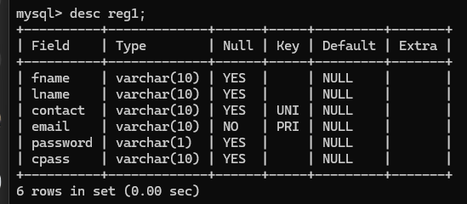

Figure.10.1.1. Database schema table

**MySQL Queries :**

**Creating database:**

**CREATE DATABASE QRIntegrity;**

**Creating Table:**

→ create table reg1 (

→ fname varchar(10),

→ name varchar(10),

→ contact varchar(10) unique,

→ email varchar(10) primary key,

→ password varchar(10),

→ cpass varchar(10));

# CHAPTER 9: CONCLUSIONS

## 9.1 CONCLUSION

1. With this method, the product journey from producing to client are often recorded, and therefore the client is assured that the scans don't seem to be faked. Manufacture is ready to prove their product is authentic and is additionally able to track their product pathway. The setup is straightforward to implement and needs less operation value. Manufacturer can even adopt RFID or NFC tokens rather than QR codes to more strengthen their system.
2. We would really like to implement this project in real time situation victimization mobile application. This project as of now's a model however within the future sweetening, we'd wish to deploy it within the public blockchain with Real time knowledge handling. we'd conjointly wish to add functionalities associated with each user and manufacturer by increasing security and choices and creating it user friendly.

## 9.2 FUTURE WORK

1. Enhanced Scalability: The relentless advancement of blockchain technology is driving a concerted effort towards bolstering its scalability. Leveraging innovative methodologies such as sharding, sidechains, or layer-two solutions, blockchain networks are poised to accommodate a substantially higher throughput of transactions. This scalability enhancement not only augments the efficiency of the fake product detection system but also ensures its scalability to meet burgeoning demands.
2. Seamless Integration with IoT: The seamless integration of Internet of Things (IoT) devices heralds a pivotal stride in product authentication methodologies. By embedding sensors or NFC chips within products, a continuous stream of real-time data can be seamlessly captured and immutably recorded onto the blockchain ledger. This amalgamation empowers perpetual monitoring of product authenticity, thereby fortifying the arsenal against counterfeit infiltration with heightened accuracy and efficacy.
3. Harnessing Machine Learning and AI: The infusion of machine learning and artificial intelligence algorithms marks a transformative leap in the realm of counterfeit product detection. These cutting-edge technologies possess the prowess to meticulously dissect intricate patterns, discern subtle anomalies, and glean invaluable insights from historical data, thus refining the detection system's efficacy and precision to unprecedented levels.
4. Fostering Global Collaboration: A unified front forged through collaborative endeavors among manufacturers, regulatory bodies, and vigilant consumers worldwide constitutes an indomitable force in combating the proliferation of counterfeit products. By fostering a culture of data sharing and stewarding the establishment of a pervasive global blockchain network, stakeholders are empowered to meticulously track and trace the trajectory of goods, pinpoint instances of fraudulent activity, and enact judicious measures in a concerted bid to safeguard consumer interests and preserve market integrity.

## 9.3 ADVANTAGES

1. Transparency: Blockchain provides a decentralized and transparent ledger that records all transactions and product information. This allows consumers, manufacturers, and regulators to verify the authenticity of a product at any point in its supply chain.
2. Immutable records: Once a transaction or product information is recorded on the blockchain, it cannot be altered or tampered with. This immutability ensures that the data related to product authenticity remains secure and trustworthy.
3. Traceability: QR codes linked to blockchain records enable easy tracing of a product's journey from its origin to the point of sale. Each step in the supply chain can be recorded and verified, allowing stakeholders to identify any unauthorized or counterfeit products.
4. Anti-counterfeiting measures: QR codes can be uniquely generated for each product and linked to its blockchain record. This uniqueness makes it extremely difficult for counterfeiters to replicate or manipulate the codes, providing an additional layer of security.
5. Enhanced consumer trust: By allowing consumers to scan QR codes and instantly verify the authenticity of a product, blockchain-based fake product detection instills confidence and trust in the brand. This transparency fosters a stronger relationship between consumers and manufacturers, leading to increased customer loyalty.
6. Efficient recall management: In case of product recalls, blockchain-based systems enable swift identification and isolation of affected products. By scanning the QR codes, manufacturers can quickly track down the specific batch or location of the counterfeit or faulty items, reducing recall costs and potential harm to consumers.
7. Regulatory compliance: Blockchain-based systems can facilitate compliance with various regulations and standards. By maintaining accurate and tamper-proof records, manufacturers can demonstrate adherence to quality control, safety, and authenticity requirements, ensuring they are in compliance with relevant regulations.
8. Data-driven insights: The data collected through blockchain-based fake product detection systems can provide valuable insights into supply chain efficiencies, consumer preferences, and potential vulnerabilities. This information can help improve overall product quality, optimize logistics, and develop targeted strategies to combat counterfeiting.

## 9.4 APPLICATIONS

1. Product Authentication: Each product is assigned a unique QR code during the manufacturing process. This code is linked to the product's digital record on the blockchain.
2. QR Code Scanning: Consumers can use a mobile application to scan the QR code on the product packaging or label. The app reads the QR code and retrieves the associated blockchain data.
3. Data Verification: The app verifies the authenticity of the product by checking the blockchain record. It confirms if the product exists in the blockchain and if its information matches the scanned code.
4. Real-time Updates: Any changes or updates made to the product's record, such as ownership transfer or quality control inspections, are recorded on the blockchain. These updates are instantly available to consumers when scanning the QR code, ensuring up to-date information.
5. Alert for Counterfeit Products: If a scanned QR code does not match any record on the blockchain or if the product is flagged as counterfeit, the app alerts the consumer. This helps in identifying and avoiding fake products.

# APPENDIX

## LIST OF ABBREVIATIONS

**ABBREVIATION** **ILLUSTRATION**

QR QUICK RESPONSE

DLT DISTRIBUTED LEDGER TECHNOLOGY

UML UNIFIED MODELING LANGUAGE

DFD DATA FLOW DIAGRAM

NFC NEAR FIELD COMMUNICATION

PIC PERIPHERAL INTERFACE CONTROLLER

dApps DECENTRALISED APPLICATIONS

RFID RADIO FREQUENCY IDENTIFICATION

SDLC SOFTWARE DEVELOPMENT LIFE CYCLE

NFR NON-FUNCTIONAL REQUIREMENT

IOT INTERNET OF THINGS

# REFERENCES

1. Sumit Tiwari “An Introduction To QR Code Technology” (2016) Dept. of Technical Education SITS Educators Society.
2. Zibin Zheng1, Shaoan Xie1, Hongning Dai2, Xiangping Chen4, and Huaimin Wang “An Overview of Blockchain Technology: Architecture, Consensus, and Future Trends”.
3. Gupta, A., Kumar, M., & Sharma, S. (2019). Blockchain and its Applications: A Review. Journal of Computer Science and Technology.
4. Koopman, P. (2020). The Impact of Counterfeit Goods on Consumer Health and Safety. International Journal of Consumer Studies.
5. Shen, S., Li, H., & Zhang, J. (2021). Blockchain-Based Anti-Counterfeiting Traceability System for Food Safety: A Review.
6. Vatansever, K., & Dogan, R. I. (2020). Blockchain-based Anti-Counterfeiting Systems: A Comprehensive Survey.
7. Wang, Y., Li, C., & Wang, Q. (2019). QR Code Recognition Technology Based on Smartphone.
8. World Economic Forum. (2018). Trade in Counterfeit and Pirated Goods: Mapping the Economic Impact. Retrieved from https://www.weforum.org/reports/trade-in-counterfeit-and-pirated-goods-mapping-the-economic-impact.
9. World Health Organization. (2017). Substandard and Falsified Medical Products. Retrieved from <https://www.who.int/news-room/fact-sheets/detail/substandard-and-falsified-medical-products>.
10. Li, L., Chen, X., Li, Y., & Zheng, Z. (2020). Blockchain-based Anti-Counterfeiting in Supply Chains: A Survey. IEEE Access.
11. Yu, Y., Zhang, J., Tang, Y., Li, Y., & Xiong, N. N. (2021). Blockchain and QR Code-Based Food Traceability System with Smart Contracts. IEEE Transactions on Industrial Informatics.
12. OECD/EUIPO. (2019). Trends in Trade in Counterfeit and Pirated Goods. Illicit Trade. Retrieved from <https://www.oecd.org/governance/illicit-trade/trends-in-trade-in-counterfeit-and-pirated-goods-9789264562409-en.html>
13. Shin, D., Park, Y., & Lim, Y. (2018). QR Code-Based Authentication Scheme for Product Provenance and Anti-Counterfeiting. Electronics.
14. De Vries, J. (2018). Blockchain-based Supply Chain Traceability in Manufacturing of Consumer Goods. International Journal of Production Research.
15. Bovitz, G., & Van Laere, T. (2019). Blockchain-enabled Traceability in the Food Supply Chain: A Systematic Literature Review. Trends in Food Science & Technology.
16. United Nations Office on Drugs and Crime. (2019). Counterfeit Goods and Organized Crime. Retrieved from <https://www.unodc.org/documents/data-and-analysis/tocta/TOCTASourcebook_PNG/TOCTA_Sourcebook_2020_Chapter6.pdf>.
17. National Institute of Standards and Technology. (2021). Blockchain Technology Overview. Retrieved from “<https://www.nist.gov/programs-projects/blockchain-technology-overview>”.
18. Xu, J., & Lu, H. (2020). Research on Anti-Counterfeiting of Agricultural Products Based on QR Code Technology. In Proceedings of the 2020 International Conference on Information Technology and Internet of Things.
19. Rathore, S., & Rani, R. (2021). Blockchain and QR Code Based Anti-Counterfeit System for Pharmaceutical Products. In Proceedings of the 2021 International Conference on Intelligent Sustainable Systems.
20. Chukwuemeka, E. P., Okolie, S. O., & Akpo, A. O. (2020). QR Code and Blockchain Technology for Anti-Counterfeit of Products. In Proceedings of the 2020 International Conference on Computational Science and Computational Intelligence.
21. Thilina, K. P. S., & Nilmini, H. D. (2021). A Blockchain Based Anti-Counterfeiting Solution using QR Codes for Pharmaceutical Products. In Proceedings of the 2021 International Conference on Advances in Computing, Communication Control and Networking.
22. Guo, Y., & Jia, W. (2020). Anti-Counterfeit System of Agricultural Products Based on QR Code and Blockchain. In Proceedings of the 2020 International Conference on Big Data, Artificial Intelligence and Internet of Things Engineering.
23. Bhatt, N., & Bhatt, S. (2019). QR Code and Blockchain Based Anti-Counterfeiting Solution. In Proceedings of the 2019 International Conference on Data Science and Engineering.
24. Chaudhary, V., & Jain, P. (2021). A Blockchain-Based Anti-Counterfeiting System using QR Codes. In Proceedings of the 2021 International Conference on Smart Systems and Inventive Technology.
25. Wu, Y., Xu, M., & Zhang, Y. (2020). Research on Anti-Counterfeiting of Medical Products Based on QR Code and Blockchain Technology. In Proceedings of the 2020 International Conference on Intelligent Medicine and Health.
26. Liu, H., & Zhang, Y. (2019). QR Code and Blockchain Technology-based Anti-Counterfeiting System. In Proceedings of the 2019 International Conference on Smart Computing and Communication.
27. Zhang, X., & Liu, Y. (2021). A Blockchain and QR Code Based Anti-Counterfeiting System for Consumer Goods. In Proceedings of the 2021 International Conference on Internet of Things, Big Data and Security.
28. Gupta, S., & Bansal, R. (2021). A Blockchain and QR Code Based Anti-Counterfeiting Solution for Luxury Products. In Proceedings of the 2021 International Conference on Blockchain Technology and Applications.
29. Ma, Y., & Chen, J. (2020). Blockchain and QR Code Based Anti-Counterfeiting System for High-Value Products. In Proceedings of the 2020 International Conference on Cyber Security and Protection of Digital Services.
30. Sun, L., & Liu, Q. (2019). An Anti-Counterfeiting System for Automotive Parts Based on QR Code and Blockchain Technology. In Proceedings of the 2019 International Conference on Automotive Engineering, Vehicle Technology and Intelligent Transport Systems.
31. Li, X., & Wang, J. (2021). QR Code and Blockchain Based Anti-Counterfeiting System for Electronics Products. In Proceedings of the 2021 International Conference on Electronics, Information and Communication Engineering.
32. Wang, Z., & Yang, L. (2020). A Blockchain and QR Code Based Anti-Counterfeiting System for Cosmetics Products. In Proceedings of the 2020 International Conference on Cosmetic Science and Technology.
33. Chen, H., & Huang, Y. (2019). Blockchain and QR Code Based Anti-Counterfeiting System for Fashion Products. In Proceedings of the 2019 International Conference on Fashion and Textile Engineering.
34. Liu, W., & Zhang, X. (2021). A Blockchain and QR Code Based Anti-Counterfeiting System for Wine Products. In Proceedings of the 2021 International Conference on Food Science and Engineering.
35. Zhang, H., & Wang, Y. (2020). QR Code and Blockchain Based Anti-Counterfeiting System for Personal Care Products. In Proceedings of the 2020 International Conference on Personal Care and Beauty Products.
36. Yang, Q., & Wu, X. (2019). A Blockchain and QR Code Based Anti-Counterfeiting System for Jewelry Products. In Proceedings of the 2019 International Conference on Jewelry Design and Manufacturing.
37. Wang, X., & Li, W. (2021). QR Code and Blockchain Based Anti-Counterfeiting System for Home Appliances Products. In Proceedings of the 2021 International Conference on Smart Home Appliances and IoT.

# PLAGIARISM REPORT

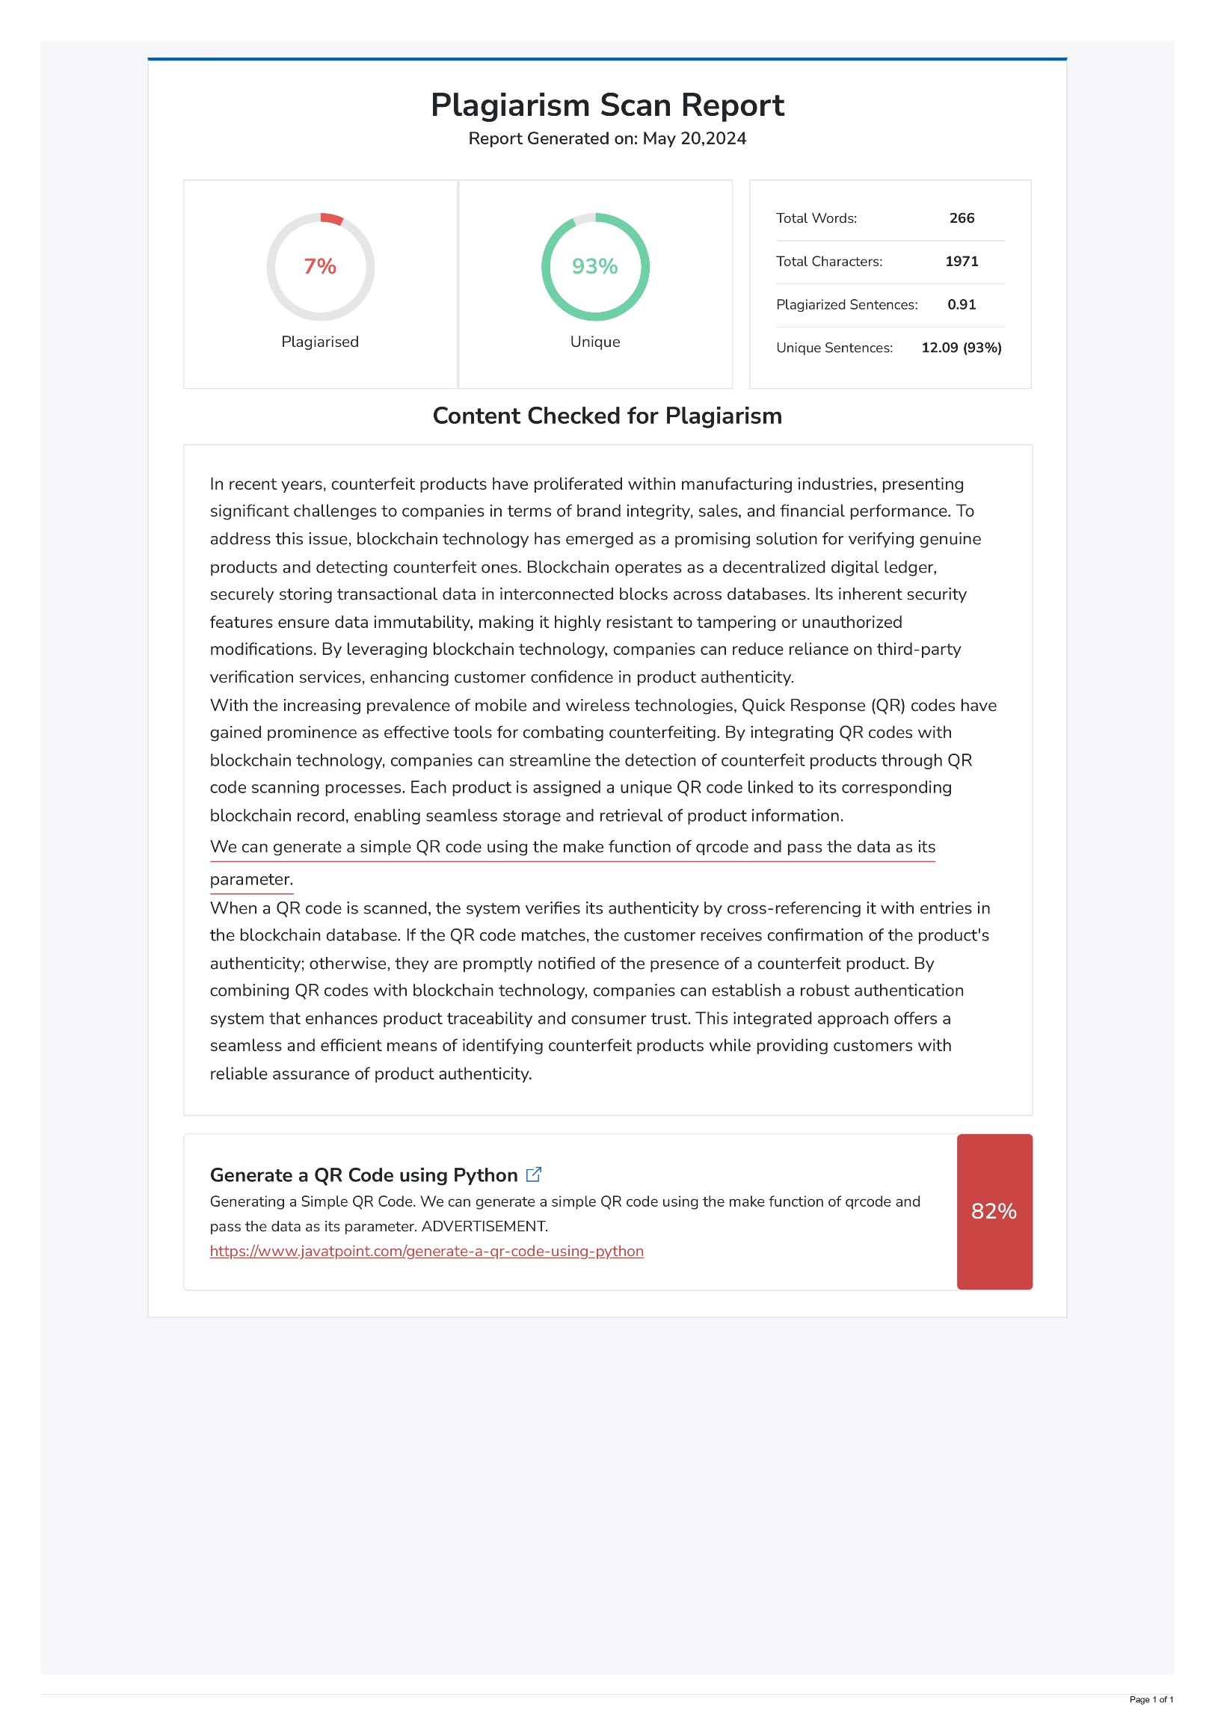

# CONTACT DETAILS

|  |  |
| --- | --- |
|  | Name: Yash Srivastava  Roll No.: 2003481520023  Phone No.: 75183 31187  Email: [iyashsrivastav@gmail.com](mailto:iyashsrivastav@gmail.com) |
|  | Name: Kunal Verma  Roll No.: 2003481520018  Phone No.: 73793 25519  Email: [vermakunal177@gmail.com](mailto:vermakunal177@gmail.com) |
|  | Name: Shiva Kumar  Roll No.: 2003481520018  Phone No.: 93696 37611  Email: [kumarshiva0707@gmail.com](mailto:kumarshiva0707@gmail.com) |
|  | Name: Adib Hussain  Roll No.: 2003481520001  Phone No.: 72708 89201  Email: [adibhussain143@gmail.com](mailto:adibhussain143@gmail.com) |